Fire Weather Service Level Specification

Season 2024–2025

Severe Weather Environmental Prediction Services

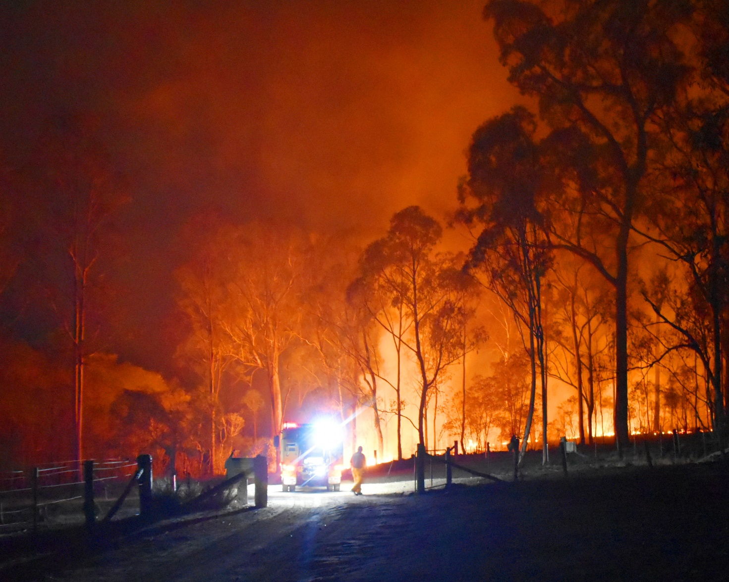

### Revision history

|  |  |  |  |
| --- | --- | --- | --- |
| Date | Version | Description | Author |
| 21/06/2023 | 2.1 | Draft for 2023 consultation | Monica Long |
| 19/09/2023 | 2.2 | Draft for external feedback | Bradley Santos |
| 18/12/2023 | 2.3 | Draft for 2023/2024 | Bradley Santos |
| 29/07/2024 | 3.1 | Draft for 2024/2025 | Rosemary Barr |
| 29/11/2024 | 3.2 | Final draft 2024/2025 | Bradley Santos |

### Review status

|  |  |  |  |
| --- | --- | --- | --- |
| Date | Version | Reviewer | Description |
| 03/02/2022 | 1.0 | Evan Morgan |  |
| 10/03/2023 | 2.0 | Evan Morgan |  |
| 12/01/2024 | 3.0 | Evan Morgan |  |
| 13/12/2024 | 4.0 | Evan Morgan |  |

### Release history

|  |  |  |  |
| --- | --- | --- | --- |
| Date | Version | Status | Approval |
| 11/02/2022 | 1.0 | Approved | Jeff Perkins (GM-EPS) |
| 14/03/2023 | 2.0 | Approved | Matt Collopy (GM EPS) |
| 16/01/2024 | 3.0 | Approved | Matt Collopy (GM EPS) |
| 17/12/2024 | 4.0 | Approved | Matt Collopy (GM EPS) |



Unless otherwise noted, all images in this document are licensed under the Creative Commons Attribution Australia Licence.

© Commonwealth of Australia 2024

Published by The Bureau of Meteorology

Cover image: Gregory Fires, Queensland, purchased under licence from iStockphoto.com

Table of contents

1. Introduction 7

1.1. Purpose 7

1.2. Scope 8

1.3. Authority 8

1.4. Distribution 8

2. National Fire Weather Services 10

2.1. Australian Fire Danger Rating System (AFDRS) 10

2.2. Partnerships 10

2.3. Fire Weather Season 10

2.4. Area of Responsibility 11

2.5. Dissemination of products 12

2.6. Briefing Services 12

2.7. Outposted Meteorologists 12

2.8. Portable Automatic Weather Stations 12

2.9. Communication and adoption activities 12

2.10. Service Continuity 12

3. Quality Assurance and Performance 13

3.1. Hazard Services Forum 13

3.2. Performance Statistics and Reporting 13

3.3. Post Event Review 13

3.4. Meteorologist Training and Competency 13

4. National Fire Weather Product Schedule 14

4.1. Fuel Data 14

4.2. Routine Services 14

4.2.1. Australian Seasonal Bushfire Outlook 14

4.2.2. Fire Danger Outlook Products 15

4.2.3. Australian Digital Forecast Database 15

4.2.4. Fire Danger Ratings 16

4.2.4.1. Purpose 16

4.2.4.2. Routine Issue and Validity Times 16

4.2.5. Fire Weather Forecast 17

4.2.5.1. Purpose 17

4.2.5.2. Routine Issue and Validity Times 17

4.2.5.3. Preliminary Fire Weather Forecast 17

4.2.5.4. Amendment Criteria for Fire Weather Forecasts and Warning 18

4.2.5.5. Content 18

4.2.6. Fire Weather Observations Bulletin 19

4.2.6.1. Purpose 19

4.2.6.2. Content 19

4.2.7. Ground Moisture Data 20

4.3. Non-Routine Services 21

4.3.1. Fire Weather Warning 21

4.3.1.1. Purpose 21

4.3.1.2. Issue Criteria, Times and Validity 21

4.3.1.3. Amendment Criteria 21

4.3.1.4. Content 21

4.3.1.5. Notes 21

4.3.2. Incident Weather Forecasts 21

4.3.2.1. Purpose 21

4.3.2.2. IWF Requests 22

4.3.2.3. Issue Time and Validity 22

4.3.2.4. Prioritisation of IWFs during busy periods 23

4.3.2.5. Guidance for Incident Weather Forecasts Amendment 24

4.3.2.6. Content 24

4.3.3. Wind Change Chart 25

4.3.3.1. Purpose 25

4.3.3.2. Issue Criteria, Times and Validity 25

4.3.3.3. Amendment Criteria 26

4.3.3.4. Content 26

4.3.3.5. Notes 27

4.3.4. Smoke Modelling 27

5. Appendix 1: Fire Danger Ratings and Fire Behaviour Indices 28

5.1. Fire Behaviour Models 28

5.2. Fire Danger Ratings 28

5.3. Determining Fire Weather District Ratings 28

6. Appendix 2: Fire Weather District Maps 29

7. Appendix 3: Product Samples 37

7.1. 4 Day Fire Danger Rating Forecast 37

7.2. 7 Day Fire Danger Rating Forecast 38

7.3. Fire Weather Forecast 40

7.4. Fire Weather Warning 44

7.5. Incident Weather Forecast 45

7.6. Incident Weather Forecast – 4 Day Outlook 47

7.7. Wind Change Charts 49

7.8. Fire Danger Outlooks 51

7.9. Ground Moisture Data 53

7.10. Fire Weather Observations Bulletin 54

8. Appendix 4: Product Identifiers 55

9. Navigation aids 68

9.1. List of figures 68

9.2. List of tables 68

9.3. List of acronyms 69

1. Introduction
   1. Purpose

The purpose of the Service Level Specification (SLS) is to document the fire weather services provided by the Bureau of Meteorology (the Bureau).

The Total Warning System[1] recognises that a fully effective warning service is multi-faceted in nature and its development and operation involves input from several agencies each with specialised roles to play. It is vital that the agencies involved work in close cooperation through all stages of developing and operating the system. The services described here are the Bureau’s contribution to the Total Warning System for fire weather.

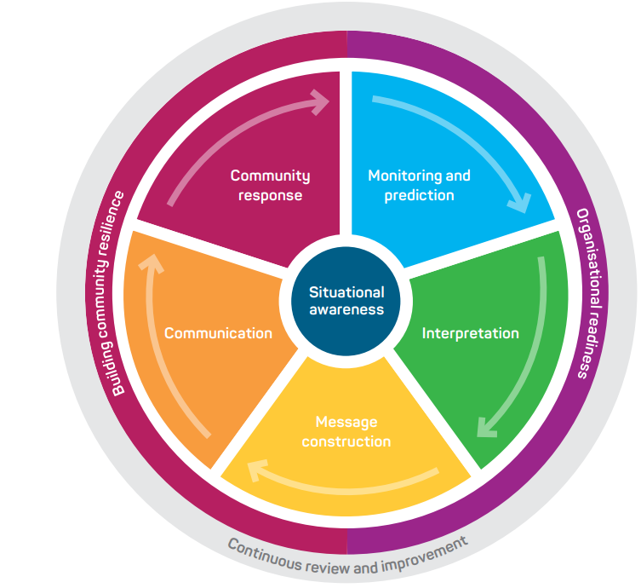

Figure 1. Total Warning System

The Bureau’s role in the fire weather warning system is focussed on monitoring and prediction, message construction and communicating threats and impacts associated with weather conditions that influence fire behaviour to Government, industry, and the community.

The Bureau also contributes to activities designed to strengthen organisational readiness and build community resilience and participates in the planning and coordination of activities with disaster mitigation agencies.

* 1. Scope

The scope of the SLS is the Bureau's publicly available fire weather services and additional services provided to support emergency management and other key stakeholders.

The SLS details what the Bureau does and when it does it, to provide fire weather services. How the Bureau produces fire weather services are addressed in internal Bureau documents.

* 1. Authority

The Meteorology Act, 1955 (Cth) provides the Bureau a number of functions including to take observations, forecast the weather and issue warnings for weather conditions including those likely to give rise to bush fires. The Intergovernmental Agreement on the Provision of Bureau of Meteorology Hazard Services to the States and Territories (IGA) confirms the roles and responsibilities of the Bureau and State and Territory governments and local governments. The Bureau has responsibility for the provision of forecasting and warning services for weather conditions likely to give rise to bush fires. The responsibility for bush fire preparation, response and warning of bush fires lies with State and Territory governments and local governments. The Schedule 2 of the IGA details the nationally agreed fire weather services.

The Bureau of Meteorology Fire Weather Service Level Specification is issued by the General Manager Environmental Prediction Services under the authority of the Director of Meteorology.

* 1. Distribution

This document will be distributed to the agencies listed in Table 1.

| Jurisdiction | Agency Name |
| --- | --- |
| National | Australasian Fire and Emergency Services Authorities Council (AFAC) – Predictive Services Group (PSG) |
| National | National Emergency Management Agency (NEMA) |
| National | Australian Energy Market Operator (AEMO) |
| National | National Broadband Network (NBN) – emergency management |
| National | Australian Energy Market Operator: AEMO |
| WA | Department of Fire and Emergency Services (DFES) |
| WA | Department of Biodiversity, Conservation and Attractions, Parks and Wildlife Service (DBCA PWS) |
| QLD | Queensland Fire Department (QFD) |
| QLD | Parks and Wildlife Service (QPWS) |
| QLD | Inspector General Emergency Management |
| NT | Police, Fire and Emergency Services (PFES) |
| NT | Bushfires NT |
| NSW | Rural Fire Service (NSW RFS) |
| NSW | National Parks and Wildlife Service (NPWS) |
| ACT | Emergency Services Authority (ACT ESA) |
| ACT | Rural Fire Service (ACT RFS) |
| ACT | Parks and Conservation (ACT PCS) |
| SA | Country Fire Service (CFS) |
| SA | Department of Environment and Water (DEW) |
| TAS | Tasmania Fire Service (TFS) |
| TAS | Tasmania Parks and Wildlife Service |
| VIC | Emergency Management Victoria (EMV) |
| VIC | Country Fire Authority (CFA) |
| VIC | Department of Energy, Environment and Climate Action (DEECA) |
| VIC | Fire Rescue Victoria |

Table 1. Fire Weather distribution list by jurisdiction

1. National Fire Weather Services

The Bureau's fire weather services provide the Australian community and emergency management with essential fire weather forecasts and warnings that are timely and accurate.

To do this, the Bureau has formed partnerships with emergency management organisations, other government authorities and media organisations across the country to ensure that forecasts are fit-for-purpose and are broadly distributed in a timely manner.

The fire weather service is designed to inform the community and counter-disaster organisations of weather conditions that will lead to dangerous fire conditions and subsequently to manage fire in the landscape. An important secondary role is to assist local media and state or territory emergency services with public education programs, and to advise on meteorological aspects of fire weather disaster preparedness and planning.

* 1. Australian Fire Danger Rating System (AFDRS)

Forecast and observed fire weather conditions are determined using the Australian Fire Danger Rating System (AFDRS). This replaces the previously used McArthur system as of September 2022.

The AFDRS calculates, forecasts and reports fire danger using fuel state data, spatial and satellite data, and weather data. It takes advantage of the many decades of research about how fire behaves, incorporating a wide range of fire behaviour models to better represent the variety of Australian vegetation and fuel types. The AFDRS is regularly improved upon using the latest science and technology in fire weather.

* 1. Partnerships

Partnerships underpin the delivery of effective fire weather services to the Australian community. The Bureau has formed partnerships with emergency management organisations, other government authorities and media organisations across the country to ensure that forecasts are fit-for-purpose and are broadly distributed in a timely manner.

The partnerships with State and Territory Governments and local government are formalised through the IGA which clarifies and confirms responsibilities across the total warning system. Specifically, the Bureau, States and Territories agreed to work together to mutually develop and maintain national standards for warnings of bush fires and Fire Danger Ratings.

State and Territory governments have responsibility for determination of Fire Danger Ratings using fuel state information determined by the jurisdictions and forecast weather provided by the Bureau.

* 1. Fire Weather Season

The season of peak fire danger varies across the country due to different climatic zones. Figure 2 broadly illustrates when peak fire danger occurs.

The peak fire danger seasons shown in the map are based on the Forest Fire Danger Index. Forest fuel is one of 8 major fuel types in the Australian Fire Danger Rating System. Fire Seasons can extend beyond the months shown. Source: [Seamless climate change projections and seasonal predictions for bushfires in Australia](https://www.publish.csiro.au/ES/ES20001) by Andrew Dowdy, Bureau of Meteorology.

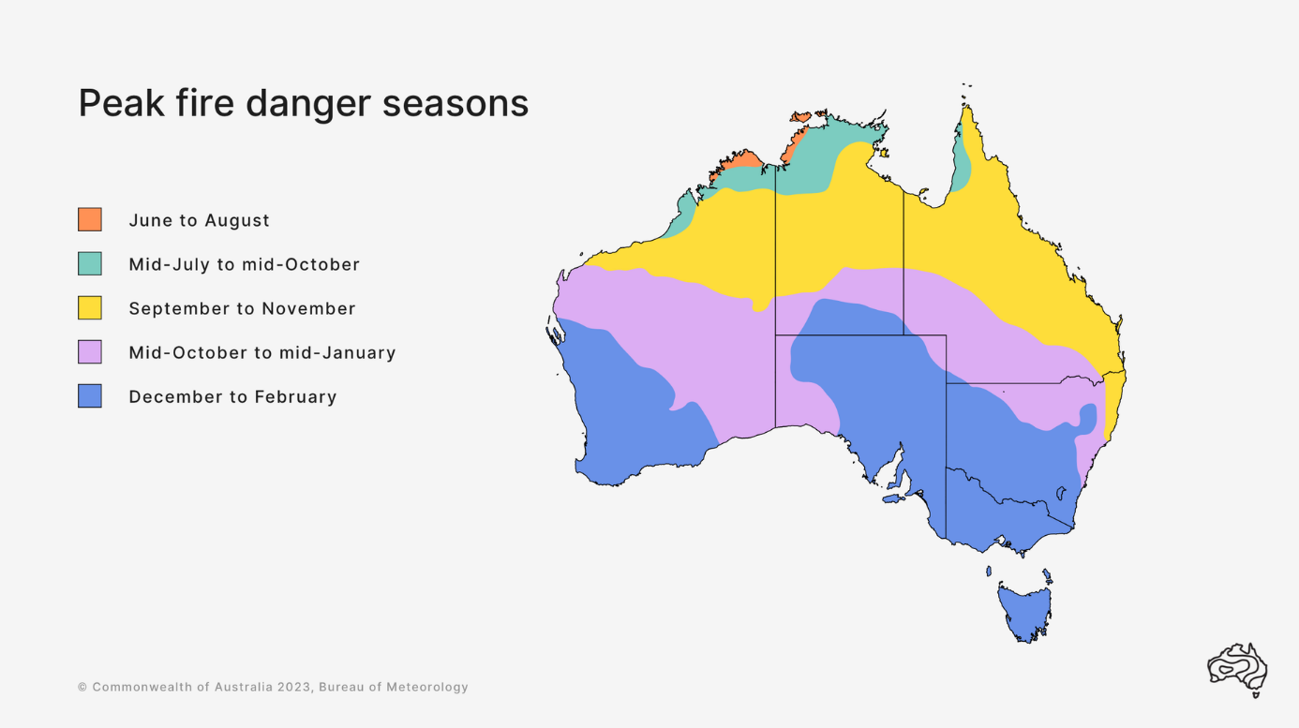

Figure 2. Peak Fire Danger Seasons across Australia.

Routine fire weather products are issued during the local fire weather season as detailed in Table 2. For those jurisdictions that do not issue fire weather products year-round, the dates are indicative, the commencement and cessation of the service will be agreed between the Bureau and local fire agencies on a season-by-season basis. A subset of products may also be issued outside of the local fire weather season below.

|  |  |  |  |  |  |  |  |
| --- | --- | --- | --- | --- | --- | --- | --- |
| State | NSW/ACT | NT | Qld | SA | Tas | Vic | WA |
| Season | Year round | Year round | Year round | Oct-Apr | Oct-May | Nov-Apr | Year round |

Table 2. Local fire seasons in each jurisdiction

Fire weather products can be issued outside of the designated fire seasons during periods of elevated fire dangers or 'spike' fire weather days. Outside of the designated fire seasons, gridded fire weather products will continue to be produced. Fire agencies need to maintain fuel state data to ensure that the output is reflective of fire weather conditions.

* 1. Area of Responsibility

The Bureau's fire weather services cover all land within Australian states, mainland territories and islands within Coastal Forecast boundaries. This is effectively a domain within 111.96°E – 155.07°E; 8.28°S – 45.03°S, as outlined in the [registered users AFDRS guide](https://reg.bom.gov.au/catalogue/fire_ADFD.pdf).

* 1. Dissemination of products

Publicly available Bureau fire weather products are transmitted via the Bureau's website and app. Products for fire agencies are transmitted by email, registered user web services and file transfer protocol (ftp).

* 1. Briefing Services

The Bureau provides briefings to Emergency Management partners to assist planning, response, and coordination. The format, timing and frequency of briefings is determined through Memorandum of Understanding (MOU) and Service Orders with each Emergency Management agency.

* 1. Outposted Meteorologists

The Bureau has arrangements with several state- and territory-based fire agencies to provide services through an outposted meteorologist to support operational awareness and communication, as well as to deepen relationships and understanding between the two organisations. Outposted meteorologists within relevant national agencies and bodies, such as those within the Australian Energy Market Operator (AEMO) and those within the National Situation Room (NSR), include fire weather within their briefings to assist in planning and preparedness for key industry sectors and broader whole-of-government response. In each instance, the services provided are agreed between the Bureau and the agency and are provided on a cost recovery basis.

* 1. Portable Automatic Weather Stations

The Bureau supports fire agencies by ingesting and displaying data from fire agency owned and operated Portable Automatic Weather Stations (PAWS) into observational product suites.

* 1. Communication and adoption activities

In addition to issuing products through standard communication channels (e.g., website, app, email), the Bureau undertakes a range of complementary communication and adoption activities in partnership with emergency management agencies. These activities are aimed to increase the uptake and effectiveness of the forecasts and warnings and ensure consistent weather safety messages are provided to the community.

This includes community, industry and government preparedness briefings, social media campaigns and the Bureau's [Fire Weather Knowledge Centre](http://www.bom.gov.au/weather-services/fire-weather-centre/) web pages. During the season this extends to joint press conferences and media interviews, as well as continuing social media public safety campaigns and community, industry and government briefings.

* 1. Service Continuity

The Bureau uses a number of strategies and contingency plans to maintain service continuity. Fire weather services are delivery by trained staff across multiple locations, allowing for service continuity in the case of failures in a specific office or team.

To maintain service continuity, the Bureau uses a large and diverse range of observational and forecast data in the delivery of its fire weather services. This provides redundancy if any individual data source is unavailable during operations and ensures all products and services are based on the best available information at all times.

1. Quality Assurance and Performance
   1. Hazard Services Forum

The IGA established the Hazards Services Forum (HSF) in 2018. The HSF facilitates consultation with State and Territory operational emergency service agencies to guide current and future strategic development of the Bureau of Meteorology’s hazard services.

The forum enables the States and Territories to request and prioritise changes to the Standard Services and to refer services that could be considered Supplementary Services to the Bureau for consideration. The HSF also assists with the process of consulting on modifications to Services Schedules.

* 1. Performance Statistics and Reporting

All official forecast and warning products are verified against available observations and compiled into routine reports. These reports investigate the accuracy and timeliness of products issued and assist the continuous improvement cycle within the Bureau.

Following fires that have had a significant impact on community safety and/or livelihoods, the Bureau may prepare a report on the meteorological aspects surrounding the event and forecast performance as part of its post event review process.

* 1. Post Event Review

The Bureau conducts internal post event reviews after fire events that have had a significant community or operational impact.

The insights and recommendations gained from these post event reviews are used to improve processes, systems and services delivered by the Bureau.

Depending on the impact from a fire event, this process may include a debrief with external partners. Upon request, the Bureau also contributes to post incident reviews conducted by emergency services and government.

* 1. Meteorologist Training and Competency

The Bureau delivers a fire weather training and competency-based assessment program for meteorologists. This program ensures that staff involved in analysing and forecasting fire weather have the qualifications, training and demonstrated ability to provide a high standard of fire weather services to the Australian community.

In addition to the formal competency-based assessment, pre-season training is provided to staff which complements existing skills and aims to enhance skills and knowledge in areas of fire weather that are complex or have rapidly evolving scientific understanding.

1. National Fire Weather Product Schedule

Fire weather services provided by the Bureau utilise gridded forecast data covering the entire Australian domain, defined in the Area of Responsibility above. The service utilises Fire Behaviour Indices derived from the AFDRS and corresponding Fire Danger Ratings at grid points across Australia to provide a measure of the level of danger of a potential bushfire at that point. These are also summarised to the Fire Weather District level and sub-area level.

Detailed information on how the Fire Behaviour Indices and Ratings are determined are included in Appendix 1: Fire Danger Ratings and Fire Behaviour Indices. For a complete listing of Fire Weather Districts, see Appendix 2: Fire Weather District Maps.

Unless otherwise noted, all issue times in this document are quoted as local time for the relevant jurisdiction and time of year.

* 1. Fuel Data

State and Territory fire agencies are responsible for providing the Bureau with fuel state data through the Fuel State Editor (FSE) to calculate forecast and observed fire behaviour indices. Agencies are responsible for checking the accuracy and validity of the fuel state data they send to the Bureau as erroneous data can affect the calculation of fire behaviour indices across the whole country.

The Bureau will update the fuel state data to ensure the most up to date information is included in fire behaviour index calculations. If erroneous data is identified in a timely manner, the Bureau will roll back to the previously correct data to ensure products can be generated. As detailed in the document "AFDRS BAU Support Arrangements", fire agencies are requested to provide any updates to fuel state data (curing, fuel load, fuel conditions, time since fire) by 8pm AEST/AEDT Fridays/Wednesdays for inclusion in fire weather forecasts (including preliminary fire weather forecasts) on Mondays/Thursdays. Changes can be made at other times, but these may cause a (significant) change in forecast FBIs/FDRs between the preliminary and official forecast and/or between the afternoon official forecast and morning update of the official forecast.

* 1. Routine Services
     1. Australian Seasonal Bushfire Outlook

The Seasonal Bushfire Outlook is a quarterly product that identifies potential areas of increased risk of bushfire based on weather, fuel and fire agency resource and management implications along with community and industry impacts, as well as other significant events.

The Bushfire Seasonal Outlook is part of the Total Warning System and informs communities of increased bushfire risk so they are aware of the risk and primed to take appropriate actions. It is not intended as a prediction of where and when bushfires will occur, nor is it intended to suggest that bushfires will not occur.

The Seasonal Bushfire Outlook is developed collaboratively by AFAC, the Bureau of Meteorology, Queensland Fire Department, the NSW Rural Fire Service, ACT Emergency Services Agency, ACT Parks and Conservation Service, VIC Country Fire Authority, Department of Energy, Environment and Climate Action Victoria, Tasmania Fire Service, SA Country Fire Service, Department of Fire and Emergency Services and Department of Biodiversity, Conservation and Attractions WA, and Bushfires NT.

The Bureau contributes Recent Conditions and Climate Outlook information within a bushfire context to assist in the production of the Seasonal Bushfire Outlook.

* + 1. Fire Danger Outlook Products

The fire danger outlook service consists of:

(a) National AFDRS index-based chance of above median and tercile map visualisations, covering the Australian land forecast domain that are updated at the same frequency as the Bureau’s temperature and rainfall outlooks (for the various outlook periods),

(b) Tercile timeseries of AFDRS intensity and index for selected land-based point locations for 5 weeks from the initialization date, and

(c) Gridded chance above median and tercile AFDRS intensity and index gridded data.

These products are provided as images and grids through registered user websites. They are released on the same schedule as the Bureau’s temperature and rainfall outlooks: Weekly outlooks issued twice weekly on Monday and Thursday, monthly and seasonal outlooks issued weekly on Thursdays.

Examples of fire danger outlooks can be found in 7.8 Fire Danger Outlooks.

* + 1. Australian Digital Forecast Database

The Bureau's Real-time Data Services provide tailored delivery of real-time Bureau of Meteorology products including datasets such as numerical output grids, satellite and radar data and web map service layers.

Part of these services is the Australian Digital Forecast Database (ADFD) which includes grids that are relevant to Fire Weather, providing detailed forecast information across all States and mainland Territories. These grids are available all year round.

The ADFD files (including AFDRS files) are typically updated routinely twice per day at around 7am and 5pm AEDT and updated at other times as required. Preliminary grids will be published at the same time as preliminary fire weather forecasts in addition to the normal afternoon official grid update. Gridded forecast data may be updated at other times during the day, and users should note the issue time of the outputs.

Further details, including information on data bundles, can be found at <http://reg.bom.gov.au/reguser/> or <http://reg.bom.gov.au/catalogue/adfdUserGuide.pdf>.

* + 1. Fire Danger Ratings
       1. Purpose

A 4-day summary of Fire Danger Ratings for each Fire Weather District is provided to the public to increase awareness of the extent to which weather conditions will enhance fire related risks for this period, to allow for forward planning of activities sensitive to fire risk and to assist with agency tactical planning. The Fire Danger Ratings are issued in consultation with the fire agency.

A 7-day Detailed Fire Danger Ratings product is made available to Emergency Service agencies. This contains ratings along with the fire behaviour index on a sub-area level for the next seven days. Agency personnel use this product to assess the fire weather risk at a state, district and sub-area level which will assist them in making operational planning and preparedness decisions in relation to the fire risk.

For details on how Fire Danger Ratings are determined, see Determining Fire Weather District Ratings.

* + - 1. Routine Issue and Validity Times

Routine issue times are summarised in Table 3. Fire Danger Ratings Issue Times (Local)

The following validity applies for each product:

* Fire Danger Ratings – 4 Day: Valid for the next 4 days when issued in the afternoon and valid for the current day and following 3 days when issued in the morning.
* Detailed Fire Danger Ratings: Valid for the next 7 days when issued in the afternoon and valid for the current day and following 6 days when issued in the morning.

| State | Afternoon Issue | Morning Issue |
| --- | --- | --- |
| NSW/ACT | 4:15 pm | 5:05 am |
| NT | 4:00 pm | 5:00 am |
| QLD | 4:00 pm | n/a |
| SA | 4:05 pm | n/a |
| TAS | 4:00 pm | n/a |
| VIC | 4:00 pm | 5:30 am |
| WA | 4:10 pm | 4:35 am |

Table 3. Fire Danger Ratings Issue Times (Local)

The public 4 Day Fire Danger Ratings are available on the Bureau's website at:

NSW/ACT: <http://www.bom.gov.au/nsw/forecasts/fire-danger-ratings.shtml>

NT: <http://www.bom.gov.au/nt/forecasts/fire-danger-ratings.shtml>

QLD: <http://www.bom.gov.au/qld/forecasts/fire-danger-ratings.shtml>

SA: <http://www.bom.gov.au/sa/forecasts/fire-danger-ratings.shtml>

TAS: <http://www.bom.gov.au/tas/forecasts/fire-danger-ratings.shtml>

VIC: <http://www.bom.gov.au/vic/forecasts/fire-danger-ratings.shtml>

WA: <http://www.bom.gov.au/wa/forecasts/fire-danger-ratings.shtml>

* + 1. Fire Weather Forecast
       1. Purpose

The Fire Weather Forecast provides fire agencies information about forecast weather parameters that are of greatest consequence to fire ignition, suppression and behaviour at a fire weather district and sub-area level.

* + - 1. Routine Issue and Validity Times

Fire Weather Forecasts are issued each afternoon during the Fire Weather season at the times in Table 4. A separate product is issued for each of the following 4 days, with a morning update for the current day issued in some states/territories.

* + - 1. Preliminary Fire Weather Forecast

When more than 1% of the grid cells in a fire weather district exceed 50 FBI, or at the request of the fire agency, a preliminary issue for the following day will be provided to agencies in the relevant state or territory. This product is intended to provide agencies with greater time to determine the final district rating that will be issued at the routine issue time, as well as giving greater time to prepare for potential elevated fire activity more generally.

A preliminary fire weather forecast uses observations and model guidance available up to the time of issue. Subsequent to this, on receipt of the latest observational data and latest model guidance the afternoon issue of fire weather forecast may contain changes.

| State/Territory | Preliminary Issue | Afternoon Issue | Morning Issue |
| --- | --- | --- | --- |
| NSW | By 12:00 pm (if catastrophic FDR forecast for Day 1), otherwise by 2:00 pm | 4:15 pm | 6:00 am |
| ACT | By 2:00 pm | 4:00 pm | 6:00 am |
| NT | By 12:30pm | 4:00 pm | 5:30 am |
| QLD | By 2:00 pm | 4:00 pm | n/a |
| SA | By 1:00pm | 4:00 pm (Day 1)  4:30 pm (Days 2-4) | n/a |
| TAS | By 12:00 pm | 4:00 pm | n/a |
| VIC | By 12:30 pm | 4:00 pm | 6:30 am |
| WA | By 12:00 pm | 4:00 pm | 4:30 am |

Table 4. Fire Weather Forecast Issue Times (Local)

* + - 1. Amendment Criteria for Fire Weather Forecasts and Warning

Fire Weather Forecasts will be monitored and, in consultation with fire agencies, updated in accordance with the below criteria.

If earlier than 11:30 am local time:

* New observance of FBI exceeding 50 Extreme for a period of 1 hour or more and is expected to persist for at least an hour, or high confidence of extreme fire danger rating affecting more than 10% of the district for at least an hour in place of a lower fire danger rating.
* New observance of FBI exceeding 100 Catastrophic for a period of 1 hour or more and is expected to persist for at least an hour, or high confidence of catastrophic fire danger rating affecting more than 10% of the district for at least an hour in place of a lower fire danger rating.
* High confidence that previously forecast Catastrophic fire danger rating will not be met. This means that all grid points within the district must be below the catastrophic fire danger rating threshold.
* High confidence that previously forecast Extreme fire danger rating will not be met. This means that all grid points within the district must be below the extreme fire danger rating threshold.

Fire Weather Forecasts for the current day will not be updated after 11:30 am local time.

An update to the Fire Weather Forecast will likely be accompanied with an update to the district ratings, in discussion with the relevant agency.

* + - 1. Content

Date/Time

Fire Weather District Summary section.

* + Fire Danger Rating
  + Maximum Sub Area Rating
  + District Fire Behaviour Index
  + cHaines[2]
  + Wind Change Danger Index
  + Thunderstorm Activity Level (TAL)[3]
  + Minor Fuel Type Rating Extreme or above
  + Text Forecast

Detailed Fire Weather District Forecast section.

* + Fuel Type and Coverage
  + FBI
  + Percentage Coverage, Start Time, and duration for significant FBI thresholds.

Fire Weather District Weather Information section.

* + Maximum Temperature
  + Minimum Relative Humidity
  + Wind Direction, Speed and Gust Strength
  + 1500m Wind Direction and Speed
  + Mixing Height (m)[4]
  + Thunderstorm Activity Level (TAL)
  + Rainfall
    1. Fire Weather Observations Bulletin
       1. Purpose

The Fire Weather Observations Bulletin displays real time weather observations and associated FDR/FBI calculations along with the details of the maximum FBI observed since local midnight. It is provided to Fire Agencies to assist with situational awareness and monitoring actual weather conditions. The bulletin is available through a Registered User Web Page with the option of selecting a state or territory. The bulletin is also available in JSON format (with additional fields). Please refer to the [Fire Weather Observation Bulletin User Guide](https://reg.bom.gov.au/catalogue/fireweatherbulletins.pdf) for further information.

* + - 1. Content

State/Territory page:

* Station
* Current Observations
  + Time (local)
  + Primary fuel type (FT 1)
  + Primary FBI/FDR
  + Secondary fuel type (FT 2)
  + Secondary FBI/FDR
  + Wind Direction and Wind Speed
  + Wind Gust
  + Relative Humidity
  + Temperature
  + Dew Point Temperature
* Max observations
  + Time (local)
  + Primary fuel type (FT 1)
  + Primary FBI/FDR
  + Time (local)
  + Secondary fuel type (FT2)
  + Secondary FBI/FDR

Historical observations for a location:

* Station name
* Primary fuel type: Fire behaviour model, Vegetation fuel type, Sub-Fuel Type code
* Secondary fuel type: Fire behaviour model, Vegetation fuel type, Sub-Fuel Type code
* Time (local)
* Primary fuel type (FT 1)
  + Primary fuel state data
  + Primary FBI/FDR
* Secondary fuel type (FT 2)
  + Secondary fuel state data
  + Secondary FBI/FDR
* Wind Direction and Wind Speed
* Wind Gust
* Temperature
* Relative Humidity
* Dew Point Temperature

Please refer to: Fire Weather Observations Bulletin for sample observational products.

Fire agencies have selected the most appropriate sub-fuel type based on a statistical analysis of the predominant fuels within 20km of each AWS location. This better aligns the observation bulletin FBI outputs with both the fire weather forecasts and IWF outputs.

Wind observations at 10, 20, 40 and 50 mins past the hour use a 1 minute averaged wind speed, rather than the standard 10 minute averaged wind speed. 1 minute averaged wind speeds can often be higher than the 10 minute averaged wind speed and so can lead to spikes in the FBIs.

* + 1. Ground Moisture Data

The Bureau provides Ground Moisture Data to fire agencies to assist with strategic planning. The data is calculated by applying dryness or drought indices to observational data and can be viewed on registered user pages and is presented in tabular and/or graphical formats, depending on the jurisdiction. See Ground Moisture Data 7.9 for a product example.

* 1. Non-Routine Services
     1. Fire Weather Warning
        1. Purpose

The Bureau issues fire weather warnings to alert the community that weather conditions are likely to make the suppression or control of fires difficult.

* + - 1. Issue Criteria, Times and Validity

Fire Weather Warnings for a Fire Weather District are issued when the Fire Danger Rating is Extreme or greater (see Fire Danger Ratings). They are issued no later than 4:15pm local time in the afternoon for either the remainder of the current day and/or the following day, with a 5:00am local time morning update covering the remainder of the current day.

* + - 1. Amendment Criteria

Fire Weather Warnings will be monitored and updated as needed at any time of day, in consultation with local fire agencies.

See 4.2.5.4 for more detail on amendment criteria.

* + - 1. Content
* Fire Weather Warning for the affected fire weather districts
* Issue time and date
* Fire/Emergency Service Organisation action statement
* Validity period
* Fire Danger Rating and affected districts
* Weather Situation
* Fire/Emergency Service Organisation link
* Next issue time
  + - 1. Notes

In consultation with fire agencies, some discretion can be applied for the issuance of a Fire Weather Warning when the FBI 50 / FDR Extreme District Fire Danger Rating criterion is not satisfied.

* + 1. Incident Weather Forecasts
       1. Purpose

Incident Weather Forecasts (IWF) are site-specific forecasts issued to assist with tactical decision making in operations. IWF are only provided to designated fire agencies and are only provided for fire (uncontrolled fires/bushfires or prescribed/hazard reduction burns), structural fires, HAZMAT operations or training purposes.

IWFs provide greater detail than is available from the Fire Danger Viewer[5] or ADFD datasets, with additional text-based information on uncertainty as well as forecasts tailored for local topography and other effects by fire weather meteorologists.

IWFs for planned/prescribed/hazard reduction burns are a cost-recovered service.

* + - 1. IWF Requests

IWFs are requested by a designated fire agency through the Bureau's online IWF request system. Any subsequent issues of an IWF require additional requests to be submitted. A follow up phone call is required after each submission to confirm receipt and provide an opportunity to discuss specific details of the incident, including any sensitivities or watch points.

Requests should be made only when the existing gridded weather forecast service via MetEye, AFDRS Fire Danger Viewer and through the ADFD is insufficient to make tactical decisions regarding the incident. Requesting officers should investigate these data sources and surrounding existing IWFs prior to submitting their request.

Where multiple IWFs are in close proximity and weather conditions are not expected to be significantly different, meteorologists may combine these into a single IWF, with comments to note any minor variations in forecast conditions.

It is highly desirable for requests to be channelled through a coordination point for each state/territory to avoid duplication and confusion. Requesting officers should be aware of the coordination arrangements for their agency and within the state/territory.

Requests should provide the best estimate possible of observed weather conditions, including location, time, temperature, dew point, relative humidity, wind (direction and speed) and weather, if available. A description of the height and type of wind observation and exposure is desirable.

An IWF request has the option to include an outlook for up to 4 days ahead. A 4-day outlook will only be included when specifically requested. In Queensland, South Australia, and Western Australia, the 4-day outlook can be requested as a separate product to the standard IWF for all types of IWF requests.

* + - 1. Issue Time and Validity

For urgent requests, usually those associated with out-of-control bushfires without a pre-existing forecast, the IWF is issued as soon as possible and generally within one hour of receiving the request. In other cases, an IWF may be issued any time between the receipt of the request and the noted start-time of the forecast. The issue time will be determined by the requirements of the incident as discussed with the requesting officer and operational requirements in the Bureau.

IWF validity period should be included in the request and can be 6hr, 12hr, 18hr, 24hr or 30hr from the forecast start time. If no validity period is included in the request, a 12hr forecast will be issued. The requesting officer can choose the period for which they want the hourly forecast data: first 12 hours, middle 12 hours or last 12 hours. If no period is chosen, the first 12 hours will be hourly forecast data.

In the case of ongoing or campaign fires requiring regular IWF updates, the Bureau will work with agencies and requesting officers to establish a routine update schedule that allows for a balanced workload. In these cases, new requests must still be submitted by the requesting officer for each forecast instance, to allow for changes to the incident location, observed conditions, requesting officer and any other variations from the previous request.

In most circumstances the schedule should generally allow for one update every 24 hours, with hourly data covering the period of highest interest. For higher priority fires, for example where there is active overnight firefighting, the Bureau may accommodate 12 hourly updates to allow for continuing hourly forecast data. In such circumstances forecasts will be issued twice per day (i.e. not prepared/issued concurrently with differing start times).

All requests need to be submitted via the online request system for each update and a phone call made to confirm receipt. Requests should not be made more than 24 hours ahead of the agreed schedule. When considering sending an update request for an ongoing fire it is important to note that all IWFs will be monitored throughout their validity and updated if required (see amendment details below).

* + - 1. Prioritisation of IWFs during busy periods

During periods where there is a significant number of fires and/or large number of IWF requests, the Bureau's Fire Weather Meteorologists will prioritise IWF preparation based on information including: the alert level of the incident, existing and valid (or nearby) IWF for the incident, and the likelihood of adverse weather conditions impacting the site. Where these methods do not identify a clear priority, the Bureau will liaise with the relevant fire agencies to clarify and prioritise forecast requirements. Where possible, agencies should complete a prioritisation and triage of forecast requests prior to contacting the Bureau with the day's requests.

For lower priority fires (including fires at or below Advice level) or fires with no active fire fighting operations, it may be more appropriate for fire agencies to access weather information from MetEye, the ADFD or Fire Danger Viewer and/or receive a briefing from Decision Support meteorologists.

When the number of IWFs is approaching a level where all subsequent requests will be subject to prioritisation and the above conditions, the Bureau will provide notification through respective state and territory Decision Support teams. The prioritisation will also extend to the monitoring of IWFs, particularly in the overnight period.

The Bureau will work with fire agencies to further develop agreed IWF prioritisation processes during times of increased demand. Any process will require real-time input from fire agencies on factors including impacts, community risk and forecast uncertainty.

* + - 1. Guidance for Incident Weather Forecasts Amendment

IWFs will be monitored and updated if one or more of the following criteria are observed and forecast to persist for at least 1 hour where conditions lead to higher FBIs than forecast, and where conditions are expected to last more than 3 hours where FBIs are expected to be lower than forecast. An amendment may also be made where there is an equivalent change in forecast conditions.

* Change in the likelihood of thunderstorms affecting the incident site.
* Change in the timing of a thunderstorm affecting the incident site.
* Change in the timing of a wind change by 1 hour or more.
* Change in temperature of 5 degrees, or agency specified temperature requirement.
* Change in dew point temperature of 5 degrees, or agency specified dew point temperature requirement.
* Change in relative humidity of 20%, when RH is below 60%, or agency specified relative humidity requirement.
* Change in wind speed of 20 km/h, or agency specified wind speed requirement.
* Change in wind direction of 45 degrees for wind speeds greater than 20 km/h, or agency specified wind speed requirement.

These guidelines apply only to the validity period of an IWF, no amendments will be issued for changes to outlook days.

When an IWF is amended, the reason is included in the Significant wind changes and uncertainties section. Local agreements between fire agencies and state/territory DSS teams will dictate guidelines around monitoring and updating of planned burns/hazard reduction IWFs.

* + - 1. Content
* Incident Details, including:
  + Issue Time (local) and date
  + Incident Type
  + Forecast Location
  + Latitude/Longitude
  + Elevation (metres ASL)
  + Fuel Type: Fire Behaviour Model and Sub-Fuel Type
  + Form Number
  + Request Number
  + Contact Phone
  + Contact Name
  + Email
  + Significant wind changes and uncertainties
  + Thunderstorm potential, precipitation, cloud, and uncertainties
  + Spatial variation of conditions and other important information

Validity Time

FBI type and Sub-Fuel Type

Fuel State Data

Tabular details including:

* Local Time
* Temperature
* Dewpoint temperature
* Relative Humidity
* 10m Wind Direction, Speed and Gust Strength
* 1000m AGL Wind Direction and Speed
* FBI (based on sub-fuel type)
* Mixing Height
* cHaines
* Thunderstorm Activity Level (TAL)

Notes on information in table:

* Notes on taking observations and liaising with forecasters.

The 4-day outlook component (if requested) includes:

* Text summary for each relevant day
* FBI type and Sub-Fuel Type
* Fuel State Data
* Tabular forecast data at time of maximum fire behaviour index and time of minimum fire behaviour index, including:
  + Time
  + Temperature
  + Dewpoint temperature
  + Relative Humidity
  + 10m Wind Direction, Speed and Gust Strength
  + 1000m AGL Wind Direction and Speed
  + FBI (based on sub-fuel type)
  + Mixing Height MSL
* Daily summary of maximum cHaines, maximum TAL, Probability of rain >5mm
  + 1. Wind Change Chart
       1. Purpose

A Wind Change Chart (WCC) is provided to fire agencies in New South Wales, South Australia, and Victoria to advise of the forecast time of a significant wind change to assist operations. The WCC also contains details of conditions ahead of and behind the change.

* + - 1. Issue Criteria, Times and Validity

A WCC service is issued on days when a significant, trackable synoptic wind change is expected to impact at least one district in the relevant state which has a forecast District Fire Behaviour Index reaching the threshold in Table 5. The validity will generally be 12 to 15 hours, but may be extended beyond this for long-lived changes. Forecasts will be reissued according to the frequency in Table 5 and cease when conditions no longer pose a significant threat to any ongoing fire.

|  |  |  |  |
| --- | --- | --- | --- |
| State | District FBI Threshold | First Issue | Following Issues |
| SA, Vic, NSW | 24 | Dependent on wind change timing, but typically by 9am local time (with an 8am local time analysis position) | 3 hourly |

Table 5. Wind Change Chart issue times (Local)

Reaching the District FBI Threshold of 24 initiates a discussion between the Bureau and the fire agencies in the relevant state regarding the need for a WCC. If there are no significant operational concerns, and therefore no need for a WCC, it would be agreed to not issue a WCC for that event. Otherwise, the WCC would be issued as described.

* + - 1. Amendment Criteria
* If the position of the wind change is significantly different to the forecast position (defined as more than 1 hour faster or slower than forecast within the next 3 hours), or the difference is likely to impact fire agencies.
* If the given wind speeds are greater than 20km/h stronger than forecast around the time of the change.
* If weather (e.g. thunderstorms) is significantly different than forecast, this should trigger a conversation with agencies via DSS teams to check if an amendment should be issued.

Amendment Methodology

* + An analysed Observed line will be added to an amended chart with the time of analysis (rounded to 30 minutes) labelled.
  + Subsequent forecast lines will be maintained at previously defined (standardised) forecast times, even if that means less than 3 hours between the observed time and the first forecast time. Adjusted accordingly based on latest available evidence.
  + In the case of an amendment 30 minutes prior to the next routine update, the first forecast line may be omitted however there will be no more than 3hrs, 30 minutes between the observed line and the first forecast line.
  + Subsequent standard issue times will be maintained, UNLESS the amendment was less than 60 minutes prior to the next standard issue time.
    - 1. Content

The WCC consists of a graphic showing a recent observed location of the wind change where this is possible and forecast locations of the wind change at 3 hour increments (once the change is within 3 hours of affecting the state) as it moves over the area of concern, accompanied by supporting text.

The first WCC may be issued with only forecast positions of the wind change if the change has not yet reached the state border. This will support morning briefing activities.

The last WCC for the day will contain the message "No further routine Wind Change Forecasts will be issued today."

* + - 1. Notes

Following consultation with fire agencies, the WCC service may be activated when FBI triggers are not met. Typically, this would be when there are significant fires.

In South Australia, the criteria for issuing only applies to the southern half of the state.

* + 1. Smoke Modelling

The Australian Smoke Dispersion System (ASDS) is available to fire agencies and is provided on a cost recovery basis. It combines bushfire, fuel reduction burn and atmospheric data with weather, fire spread and chemical transport models to estimate the likely concentration and distribution of smoke at ground level from a range of sources.

Features of the service include:

* Point-specific deterministic and ensemble fire weather information for the next 6 days for specified locations at 3-hourly intervals.
* Point-specific upper atmosphere data shown as aerological diagrams for the next 3 days for specified locations at 3-hourly intervals.
* Gridded ventilation parameters for the next 3 days using an 11 km grid at 3-hourly intervals.
  + Ventilation index
  + Atmospheric boundary layer height
  + Transport wind
* Gridded pollutant forecasts for the next day at hourly intervals.
  + Smoke (levoglucosan)
  + PM2.5
  + PM10
  + Ozone
  + Sulphur Dioxide
  + Carbon Monoxide
  + PM2.5 24 hour rolling average
* Gridded pollution forecasts for the next 24 hours at hourly intervals for prescribed burn sites, based on the size and fuel of the burn.

1. Appendix 1: Fire Danger Ratings and Fire Behaviour Indices
   1. Fire Behaviour Models

Fire behaviour model guides for the 8 main fuel types in AFDRS are available through the AFAC web page: <https://www.afac.com.au/initiative/afdrs/article/bom-fire-behaviour-model-guides>.

* 1. Fire Danger Ratings

Fire Danger Ratings are assigned according to the corresponding Fire Behaviour Index values in Table 6.

|  |  |
| --- | --- |
| **FDR level** | **FBI range** |
| No Rating | 0-11 |
| Moderate | 12-23 |
| High | 24-49 |
| Extreme | 50-99 |
| Catastrophic | 100+ |

Table 6. Fire Danger Ratings and Fire Behaviour Index values

* 1. Determining Fire Weather District Ratings
* Fire Behaviour Indices are calculated according to the relevant FBI formulas for each forecast grid cell at hourly time intervals.
* The Maximum FBI (MaxFBI) across each day is determined for each grid cell, according to the relevant fuel type (as advised by local fire agencies).
* The Maximum FDR is determined for each grid cell based on the MaxFBI, corresponding FDR and relevant fuel type.
* The highest Maximum FDR met or exceeded by at least 10% of grid cells in a district determines the Fire Danger Rating for that District.
* The local Hazard Management Agency (HMA) responsible for fire weather has absolute discretion to vary the District Fire Danger Rating from the value determined by this method. Liaison arrangements between the Bureau and agencies for the final determination of District Fire Danger Ratings are agreed to at a local level.

1. Appendix 2: Fire Weather District Maps

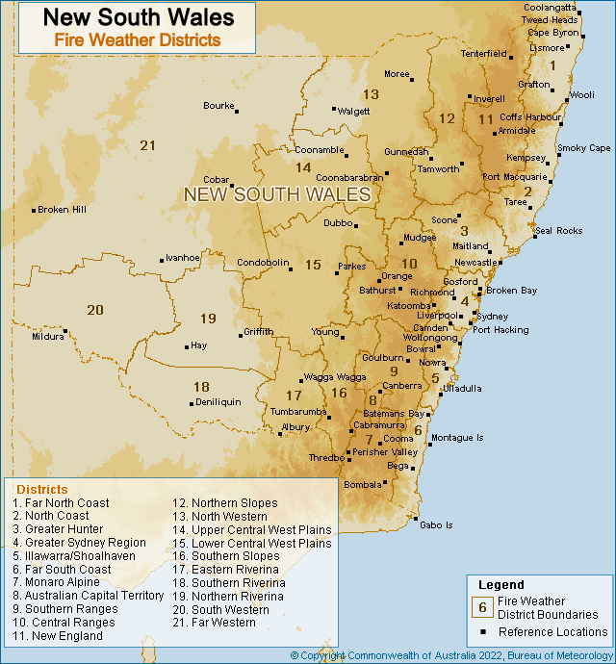

Figure 3. New South Wales Fire Weather Districts

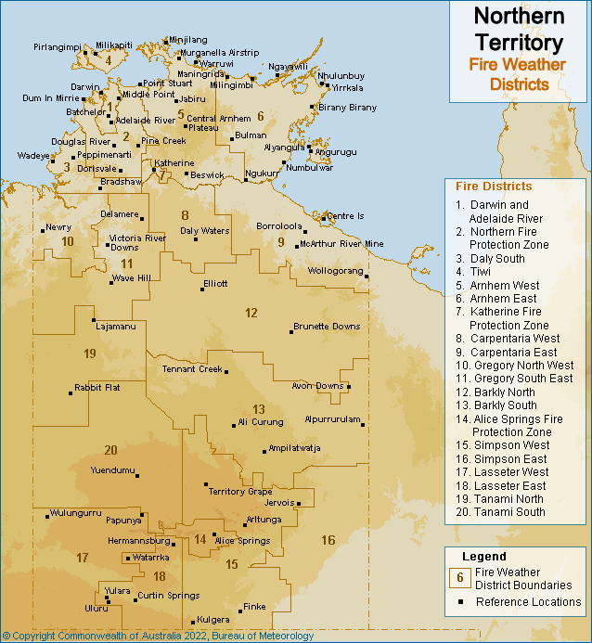

Figure 4. Northern Territory Fire Weather Districts

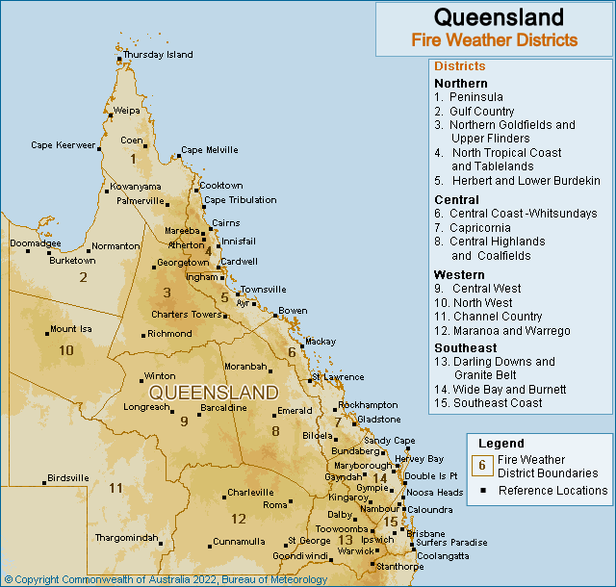

Figure 5. Queensland Fire Weather Districts

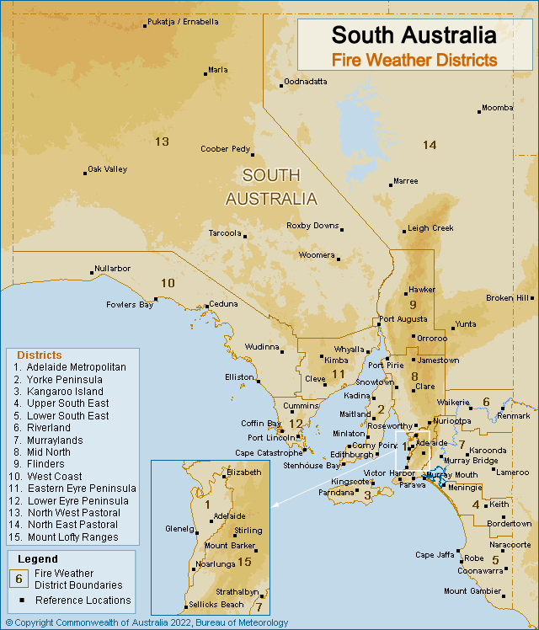

Figure 6. South Australia Fire Weather Districts

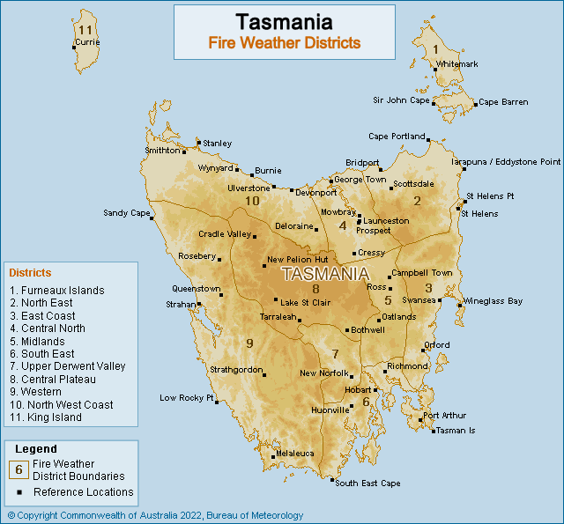

Figure 7. Tasmania Fire Weather Districts

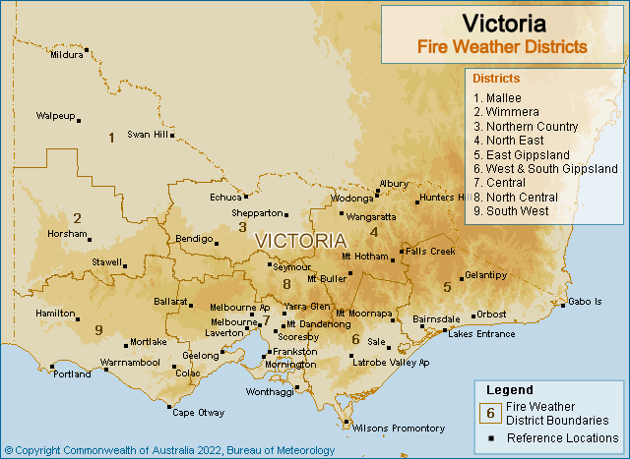

Figure 8. Victoria Fire Weather Districts

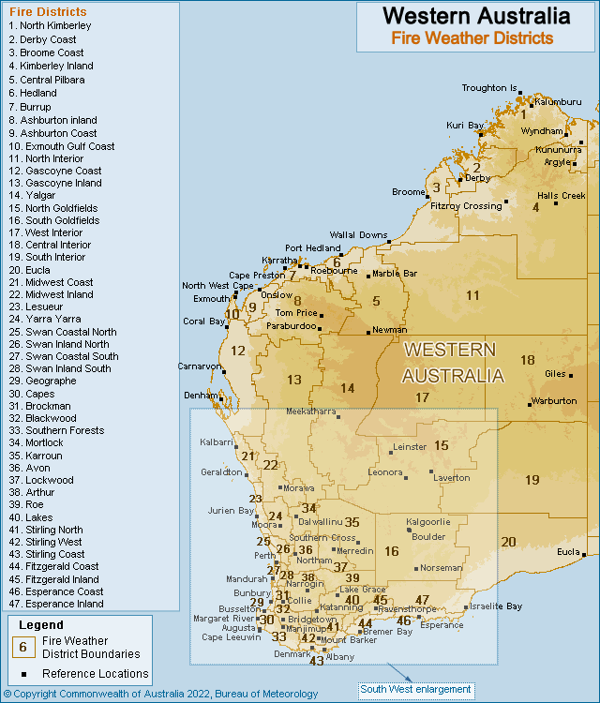

Figure 9. Western Australia Fire Weather Districts

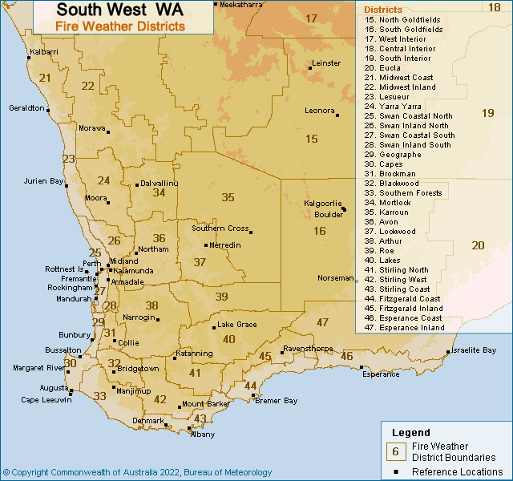

Figure 10. South West WA Fire Weather Districts

1. Appendix 3: Product Samples
   1. 4 Day Fire Danger Rating Forecast

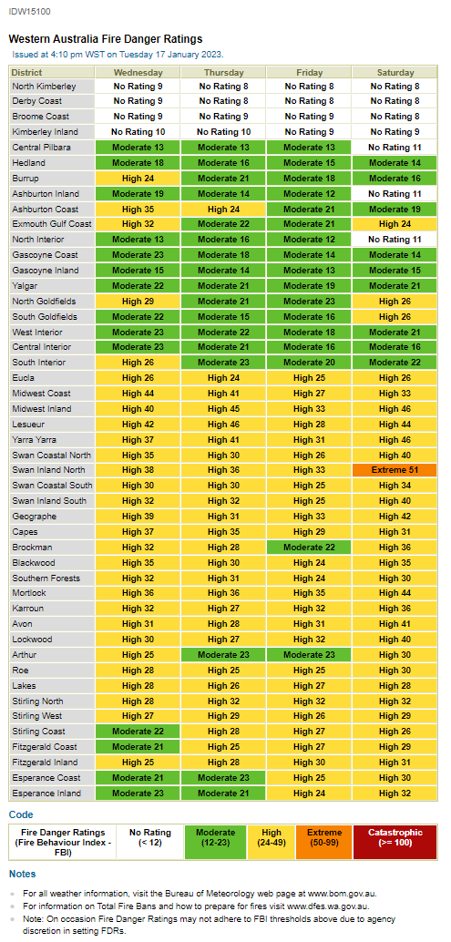

* 1. 7 Day Fire Danger Rating Forecast

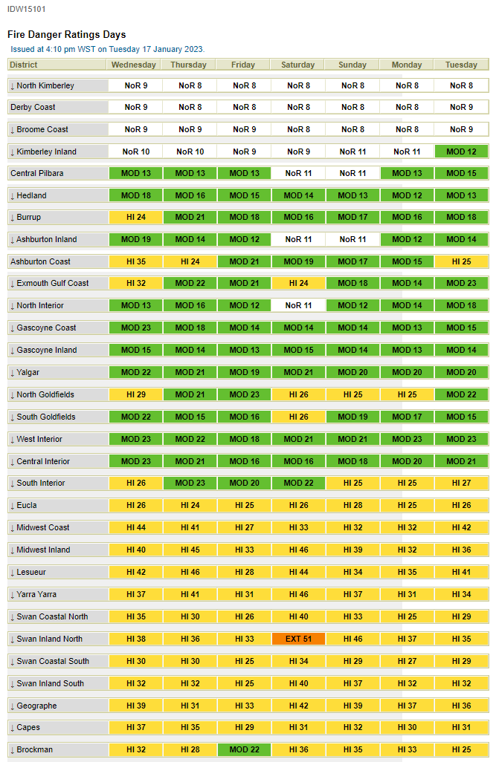

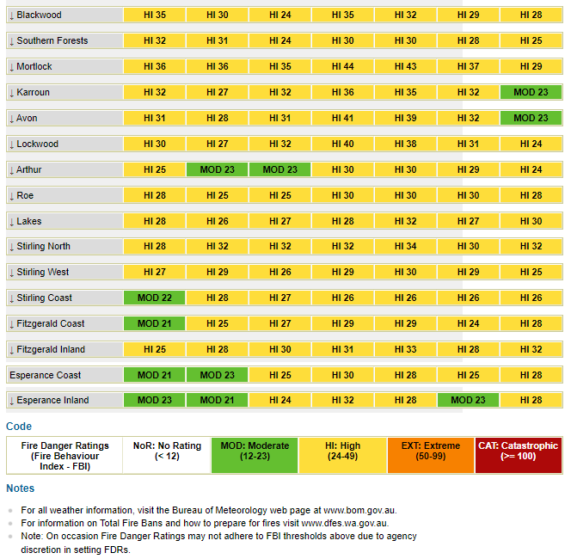

* 1. Fire Weather Forecast

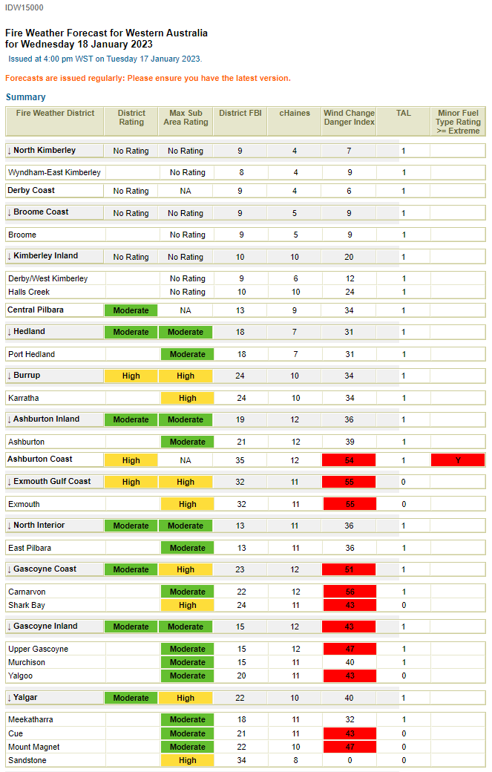

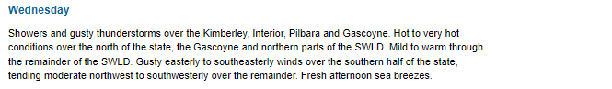

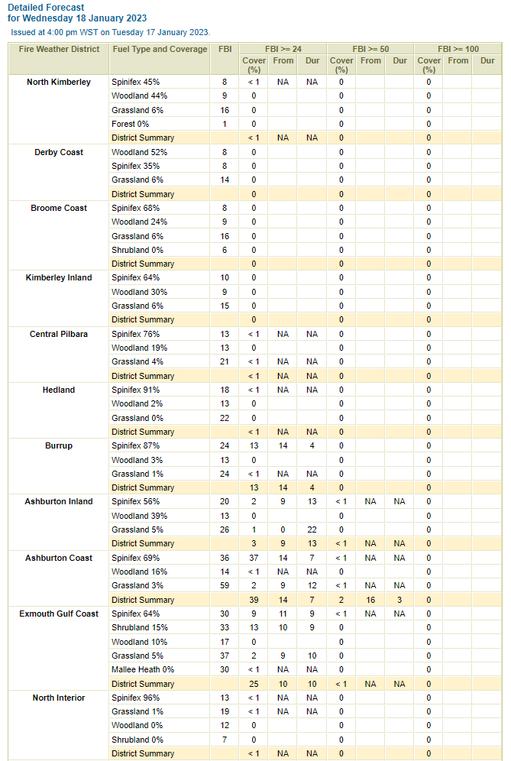

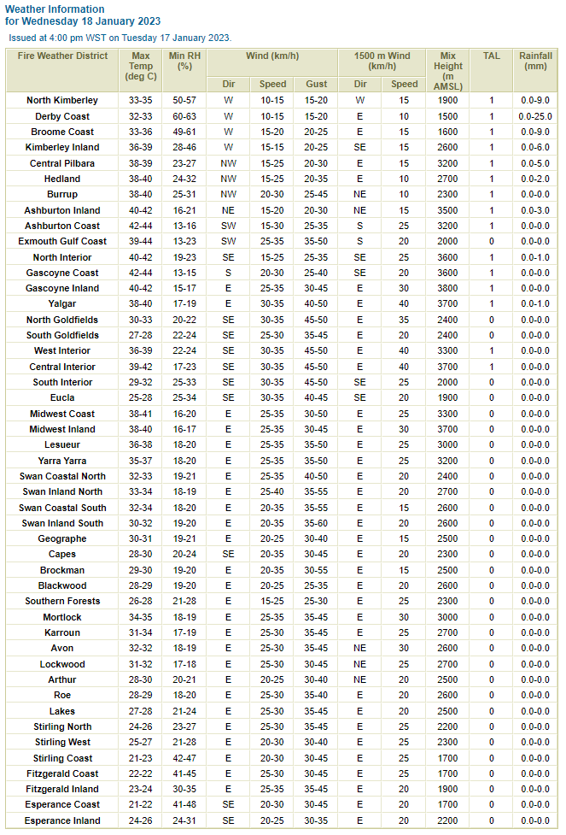

* 1. Fire Weather Warning

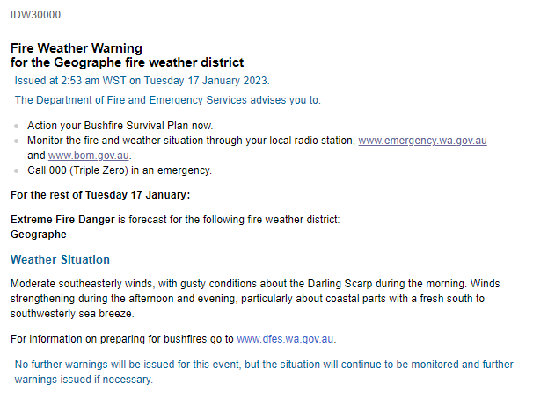

* 1. Incident Weather Forecast

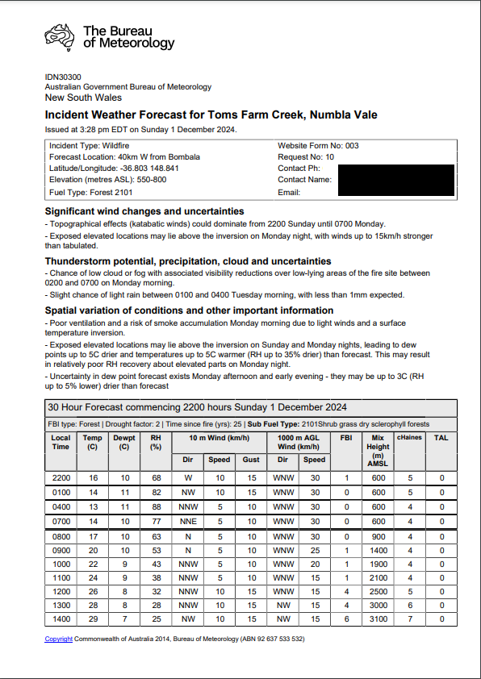

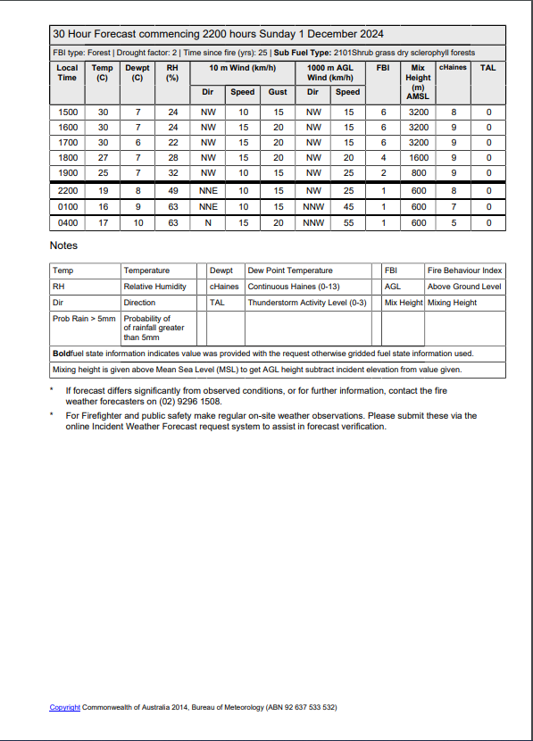

* 1. Incident Weather Forecast – 4 Day Outlook

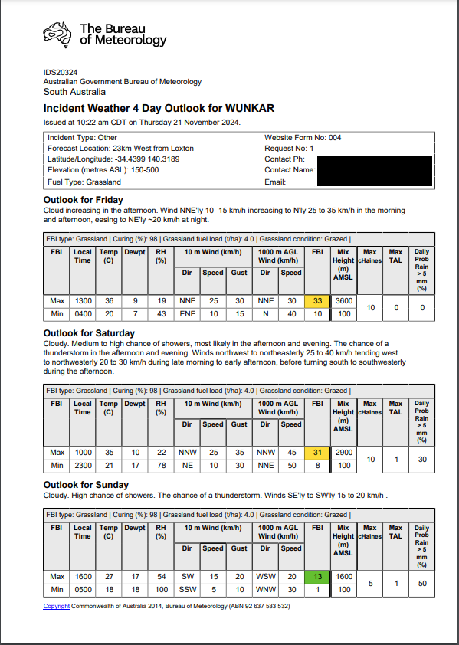

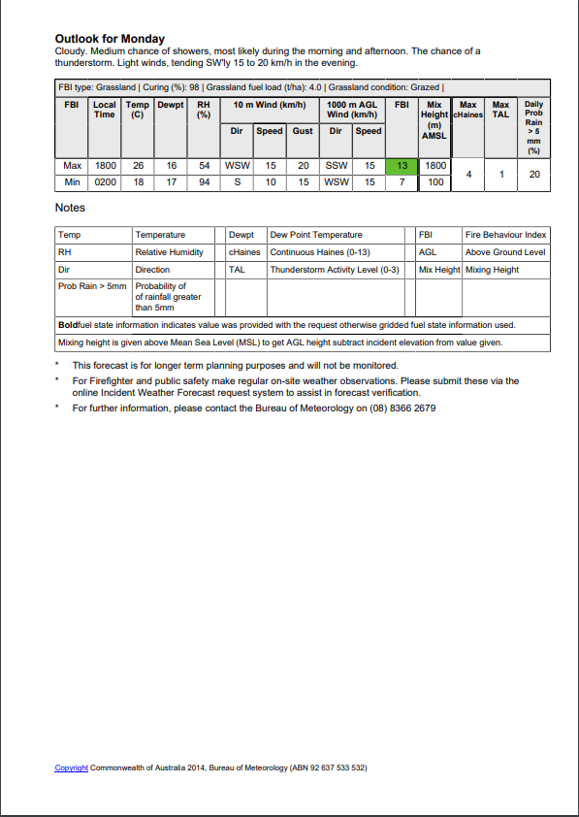

* 1. Wind Change Charts

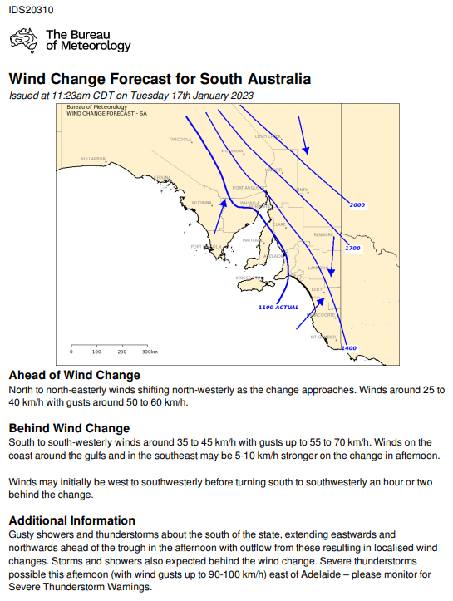

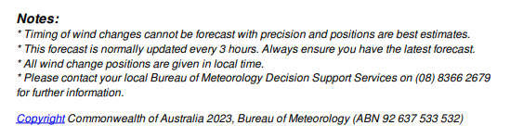

* 1. Fire Danger Outlooks

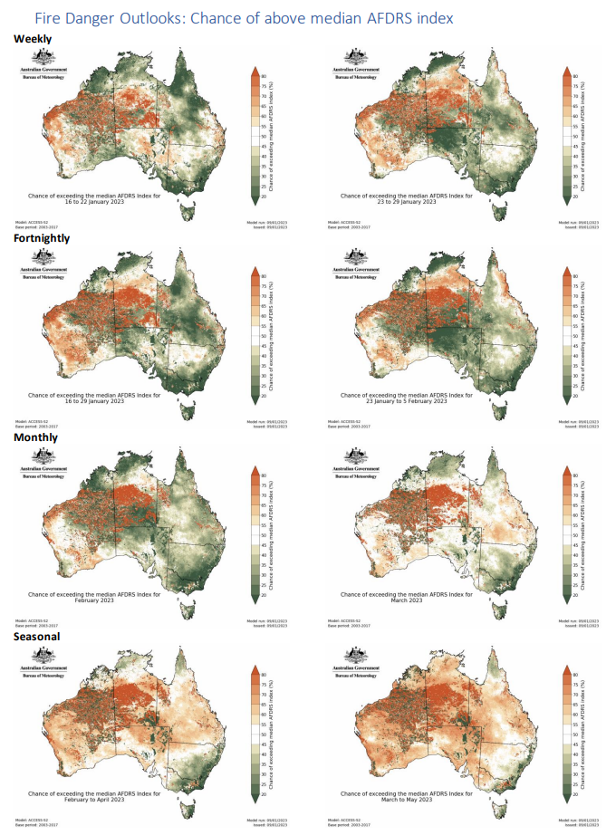

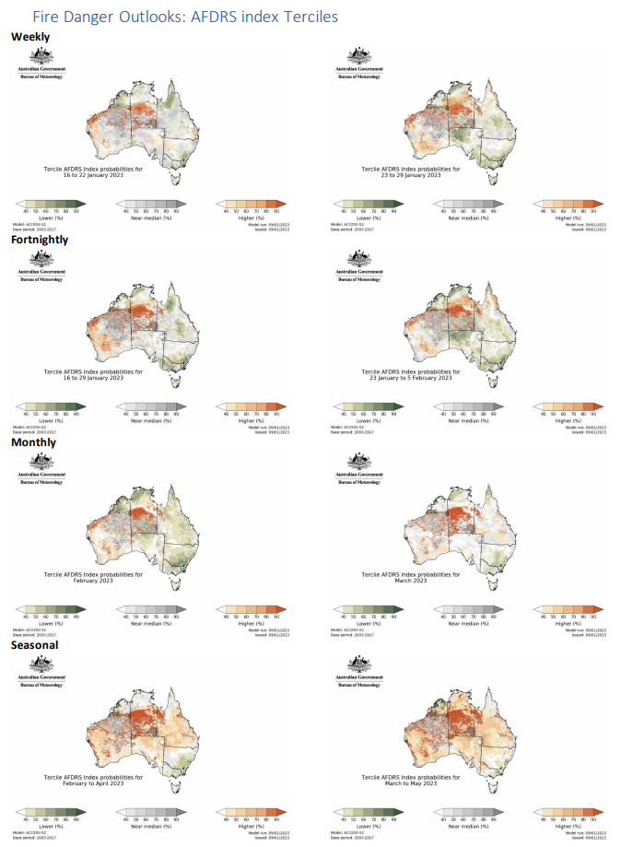

* 1. Ground Moisture Data

Example from Western Australia. Subset of the full dataset.

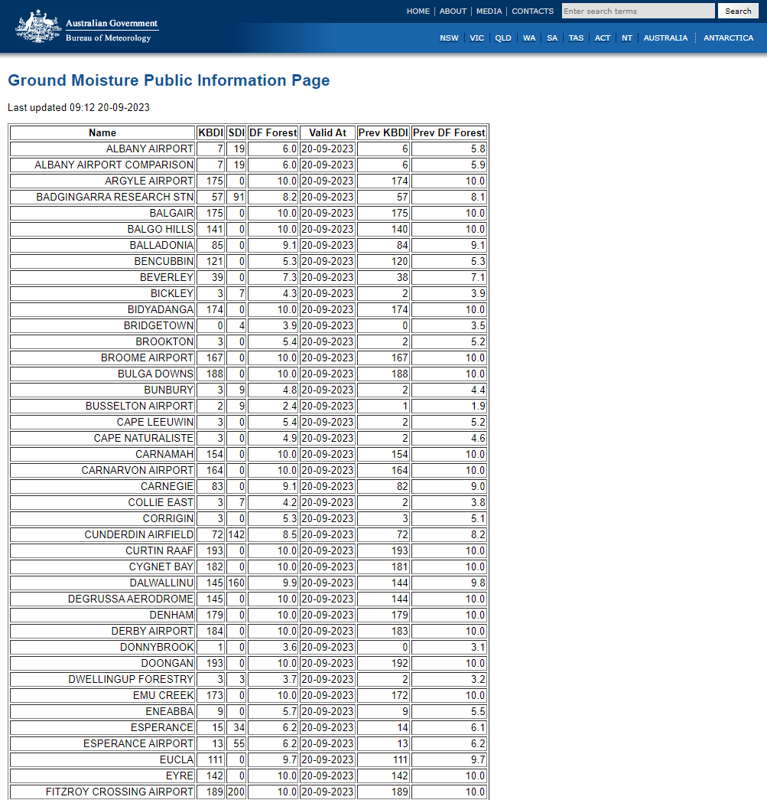

* 1. Fire Weather Observations Bulletin

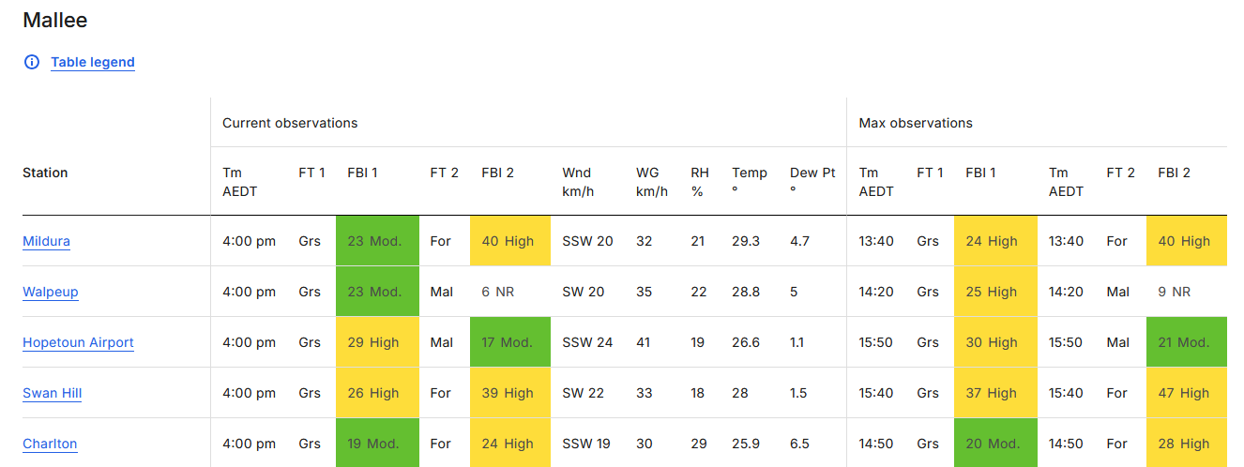

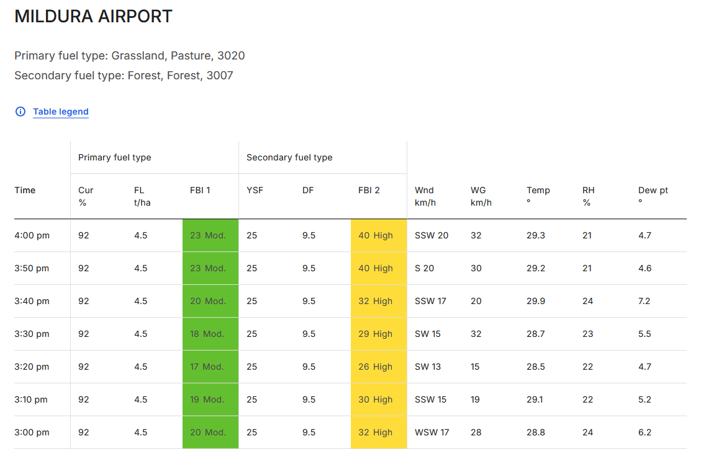

1. Appendix 4: Product Identifiers

| Product ID | Description |
| --- | --- |
| Fire Weather Forecasts for Australia | |
| IDZ20081 | Fire Weather Observation Bulletin |
| Fire Weather Forecasts for NSW | |
| IDN10017 | Day 0/1 Preliminary Forecast |
| IDN10018 | Day 0/1 Forecast |
| IDN10020 | Day 1/2 Outlook |
| IDN10021 | Day 2/3 Outlook |
| IDN10022 | Day 3/4 Outlook |
| Fire Weather Forecasts for ACT | |
| IDN29199 | Day 0/1 Preliminary Forecast |
| IDN29200 | Day 0/1 Forecast |
| IDN29201 | Day 1/2 Outlook |
| IDN29202 | Day 2/3 Outlook |
| IDN29203 | Day 3/4 Outlook |
| Fire Danger Ratings NSW/ACT | |
| IDN10016 | Fire Danger Ratings 4 Days |
| IDN10026 | Detailed Fire Danger Ratings 7 Days |
| Warnings NSW/ACT | |
| IDN22000 | NSW Fire Weather Warning 1 |
| IDN22001 | NSW Fire Weather Warning 2 |
| IDN22200 | ACT Fire Weather Warning |
| Wind Change Chart NSW/ACT | |
| IDN65171 | Wind Change Forecast for New South Wales |
| Incident Weather Forecasts NSW/ACT | |
| IDN30100 | Incident Weather Forecast 1 |
| IDN30200 | Incident Weather Forecast 2 |
| IDN30300 | Incident Weather Forecast 3 |
| IDN30400 | Incident Weather Forecast 4 |
| IDN30500 | Incident Weather Forecast 5 |
| IDN30600 | Incident Weather Forecast 6 |
| IDN30700 | Incident Weather Forecast 7 |
| IDN30800 | Incident Weather Forecast 8 |
| IDN30900 | Incident Weather Forecast 9 |
| IDN31000 | Incident Weather Forecast 10 |
| IDN31100 | Incident Weather Forecast 11 |
| IDN31200 | Incident Weather Forecast 12 |
| IDN31300 | Incident Weather Forecast 13 |
| IDN31400 | Incident Weather Forecast 14 |
| IDN31500 | Incident Weather Forecast 15 |
| IDN31600 | Incident Weather Forecast 16 |
| IDN31700 | Incident Weather Forecast 17 |
| IDN31800 | Incident Weather Forecast 18 |
| IDN31900 | Incident Weather Forecast 19 |
| IDN32000 | Incident Weather Forecast 20 |
| IDN32100 | Incident Weather Forecast 21 |
| IDN32200 | Incident Weather Forecast 22 |
| IDN32300 | Incident Weather Forecast 23 |
| IDN32400 | Incident Weather Forecast 24 |
| IDN32500 | Incident Weather Forecast 25 |
| IDN32600 | Incident Weather Forecast 26 |
| IDN32700 | Incident Weather Forecast 27 |
| IDN32800 | Incident Weather Forecast 28 |
| IDN32900 | Incident Weather Forecast 29 |
| IDN33000 | Incident Weather Forecast 30 |
| IDN33100 | Incident Weather Forecast 31 |
| IDN33200 | Incident Weather Forecast 32 |
| IDN33300 | Incident Weather Forecast 33 |
| IDN33400 | Incident Weather Forecast 34 |
| IDN33500 | Incident Weather Forecast 35 |
| IDN33600 | Incident Weather Forecast 36 |
| IDN33700 | Incident Weather Forecast 37 |
| IDN33800 | Incident Weather Forecast 38 |
| IDN33900 | Incident Weather Forecast 39 |
| IDN34000 | Incident Weather Forecast 40 |
| IDN34100 | Incident Weather Forecast 41 |
| IDN34200 | Incident Weather Forecast 42 |
| IDN34300 | Incident Weather Forecast 43 |
| IDN34400 | Incident Weather Forecast 44 |
| IDN34500 | Incident Weather Forecast 45 |
| IDN34600 | Incident Weather Forecast 46 |
| IDN34700 | Incident Weather Forecast 47 |
| IDN34800 | Incident Weather Forecast 48 |
| IDN34900 | Incident Weather Forecast 49 |
| IDN35000 | Incident Weather Forecast 50 |
| Fire Weather Forecasts NT | |
| IDD10720 | Day 0/1 Preliminary Forecast |
| IDD10721 | Day 0/1 Forecast |
| IDD10722 | Day 1/2 Outlook |
| IDD10723 | Day 2/3 Outlook |
| IDD10724 | Day 3/4 Outlook |
| Fire Danger Ratings NT | |
| IDD10731 | Fire Danger Ratings 4 Days |
| IDD10732 | Detailed Fire Danger Ratings 7 Days |
| Warnings NT | |
| IDD20320 | Fire Weather Warning 1 |
| IDD20330 | Fire Weather Warning 2 |
| Incident Weather Forecasts NT | |
| IDD20340 | Incident Weather Forecast 1 |
| IDD20341 | Incident Weather Forecast 2 |
| IDD20342 | Incident Weather Forecast 3 |
| IDD20343 | Incident Weather Forecast 4 |
| IDD20344 | Incident Weather Forecast 5 |
| IDD20345 | Incident Weather Forecast 6 |
| IDD20346 | Incident Weather Forecast 7 |
| IDD20347 | Incident Weather Forecast 8 |
| IDD20348 | Incident Weather Forecast 9 |
| IDD20349 | Incident Weather Forecast 10 |
| IDD20351 | Incident Weather Forecast 11 |
| IDD20352 | Incident Weather Forecast 12 |
| IDD20353 | Incident Weather Forecast 13 |
| IDD20354 | Incident Weather Forecast 14 |
| IDD20355 | Incident Weather Forecast 15 |
| IDD20356 | Incident Weather Forecast 16 |
| IDD20357 | Incident Weather Forecast 17 |
| IDD20358 | Incident Weather Forecast 18 |
| IDD20359 | Incident Weather Forecast 19 |
| IDD20360 | Incident Weather Forecast 20 |
| Fire Weather Forecasts QLD | |
| IDQ13014 | Day 0/1 Preliminary Forecast |
| IDQ13010 | Day 0/1 Forecast |
| IDQ13011 | Day 1/2 Outlook |
| IDQ13012 | Day 2/3 Outlook |
| IDQ13013 | Day 3/4 Outlook |
| Fire Danger Ratings QLD | |
| IDQ13016 | Fire Danger Ratings 4 Days |
| IDQ13017 | Detailed Fire Danger Ratings 7 Days |
| Warnings QLD | |
| IDQ20035 | Fire Weather Warning 1 |
| IQD20036 | Fire Weather Warning 2 |
| Incident Weather Forecasts QLD | |
| IDQ20100 | Incident Weather Forecast 1 |
| IDQ20101 | Incident Weather Forecast 2 |
| IDQ20102 | Incident Weather Forecast 3 |
| IDQ20103 | Incident Weather Forecast 4 |
| IDQ20104 | Incident Weather Forecast 5 |
| IDQ20105 | Incident Weather Forecast 6 |
| IDQ20106 | Incident Weather Forecast 7 |
| IDQ20107 | Incident Weather Forecast 8 |
| IDQ20108 | Incident Weather Forecast 9 |
| IDQ20109 | Incident Weather Forecast 10 |
| IDQ20110 | Incident Weather Forecast 11 |
| IDQ20111 | Incident Weather Forecast 12 |
| IDQ20112 | Incident Weather Forecast 13 |
| IDQ20113 | Incident Weather Forecast 14 |
| IDQ20114 | Incident Weather Forecast 15 |
| IDQ20115 | Incident Weather Forecast 16 |
| IDQ20116 | Incident Weather Forecast 17 |
| IDQ20117 | Incident Weather Forecast 18 |
| IDQ20118 | Incident Weather Forecast 19 |
| IDQ20119 | Incident Weather Forecast 20 |
| Incident Weather 4 Day Forecasts QLD | |
| IDQ20140 | Incident Weather 4 Day Forecast 1 |
| IDQ20141 | Incident Weather 4 Day Forecast 2 |
| IDQ20142 | Incident Weather 4 Day Forecast 3 |
| IDQ20143 | Incident Weather 4 Day Forecast 4 |
| IDQ20144 | Incident Weather 4 Day Forecast 5 |
| IDQ20145 | Incident Weather 4 Day Forecast 6 |
| IDQ20146 | Incident Weather 4 Day Forecast 7 |
| IDQ20147 | Incident Weather 4 Day Forecast 8 |
| IDQ20148 | Incident Weather 4 Day Forecast 9 |
| IDQ20149 | Incident Weather 4 Day Forecast 10 |
| IDQ20150 | Incident Weather 4 Day Forecast 11 |
| IDQ20151 | Incident Weather 4 Day Forecast 12 |
| IDQ20152 | Incident Weather 4 Day Forecast 13 |
| IDQ20153 | Incident Weather 4 Day Forecast 14 |
| IDQ20154 | Incident Weather 4 Day Forecast 15 |
| IDQ20155 | Incident Weather 4 Day Forecast 16 |
| IDQ20156 | Incident Weather 4 Day Forecast 17 |
| IDQ20157 | Incident Weather 4 Day Forecast 18 |
| IDQ20158 | Incident Weather 4 Day Forecast 19 |
| IDQ20159 | Incident Weather 4 Day Forecast 20 |
| Fire Weather Forecasts SA | |
| IDS65310 | Day 0/1 Preliminary Forecast |
| IDS65006 | Day 0/1 Forecast |
| IDS65307 | Day 1/2 Outlook |
| IDS65308 | Day 2/3 Outlook |
| IDS65309 | Day 3/4 Outlook |
| Fire Danger Ratings SA | |
| IDS10070 | Fire Danger Ratings 4 Day |
| IDS10080 | Detailed Fire Danger Ratings 7 Day |
| Warnings SA | |
| IDS20290 | Fire Weather Warning 1 |
| IDS20299 | Fire Weather Warning 2 |
| Wind Change Chart SA | |
| IDS20310 | Wind Change Forecast for South Australia |
| Incident Weather Forecasts SA | |
| IDS20311 | Incident Weather Forecast 1 |
| IDS20312 | Incident Weather Forecast 2 |
| IDS20313 | Incident Weather Forecast 3 |
| IDS20314 | Incident Weather Forecast 4 |
| IDS20315 | Incident Weather Forecast 5 |
| IDS20316 | Incident Weather Forecast 6 |
| IDS20317 | Incident Weather Forecast 7 |
| IDS20318 | Incident Weather Forecast 8 |
| IDS20319 | Incident Weather Forecast 9 |
| IDS20320 | Incident Weather Forecast 10 |
| IDS20330 | Incident Weather Forecast 11 |
| IDS20331 | Incident Weather Forecast 12 |
| IDS20332 | Incident Weather Forecast 13 |
| IDS20333 | Incident Weather Forecast 14 |
| IDS20334 | Incident Weather Forecast 15 |
| IDS20335 | Incident Weather Forecast 16 |
| IDS20336 | Incident Weather Forecast 17 |
| IDS20337 | Incident Weather Forecast 18 |
| IDS20338 | Incident Weather Forecast 19 |
| IDS20339 | Incident Weather Forecast 20 |
| Incident Weather 4 Day Forecasts SA | |
| IDS20321 | Incident Weather 4 Day Forecast 1 |
| IDS20322 | Incident Weather 4 Day Forecast 2 |
| IDS20323 | Incident Weather 4 Day Forecast 3 |
| IDS20324 | Incident Weather 4 Day Forecast 4 |
| IDS20325 | Incident Weather 4 Day Forecast 5 |
| IDS20326 | Incident Weather 4 Day Forecast 6 |
| IDS20327 | Incident Weather 4 Day Forecast 7 |
| IDS20328 | Incident Weather 4 Day Forecast 8 |
| IDS20329 | Incident Weather 4 Day Forecast 9 |
| IDS20343 | Incident Weather 4 Day Forecast 10 |
| Fire Weather Forecasts TAS | |
| IDT13134 | Day 0/1 Preliminary Forecast |
| IDT13130 | Day 0/1 Forecast |
| IDT13131 | Day 1/2 Outlook |
| IDT13132 | Day 2/3 Outlook |
| IDT13133 | Day 3/4 Outlook |
| Fire Danger Ratings TAS | |
| IDT13151 | Fire Danger Ratings 4 Days |
| IDT13152 | Detailed Fire Danger Ratings 7 Days |
| Warnings TAS | |
| IDT31100 | Fire Weather Warning 1 |
| IDT31200 | Fire Weather Warning 2 |
| Incident Weather Forecasts TAS | |
| IDT31000 | Incident Weather Forecast 1 |
| IDT31005 | Incident Weather Forecast 2 |
| IDT31010 | Incident Weather Forecast 3 |
| IDT31015 | Incident Weather Forecast 4 |
| IDT31020 | Incident Weather Forecast 5 |
| IDT31025 | Incident Weather Forecast 6 |
| IDT31030 | Incident Weather Forecast 7 |
| IDT31035 | Incident Weather Forecast 8 |
| IDT31040 | Incident Weather Forecast 9 |
| IDT31045 | Incident Weather Forecast 10 |
| IDT31050 | Incident Weather Forecast 11 |
| IDT31055 | Incident Weather Forecast 12 |
| IDT31060 | Incident Weather Forecast 13 |
| IDT31065 | Incident Weather Forecast 14 |
| IDT31070 | Incident Weather Forecast 15 |
| IDT31075 | Incident Weather Forecast 16 |
| IDT31080 | Incident Weather Forecast 17 |
| IDT31085 | Incident Weather Forecast 18 |
| IDT31090 | Incident Weather Forecast 19 |
| IDT31095 | Incident Weather Forecast 20 |
| Fire Weather Forecasts VIC | |
| IDV22010 | Day 0/1 Preliminary Forecast |
| IDV18560 | Day 0/1 Forecast |
| IDV18570 | Day 1/2 Outlook |
| IDV18580 | Day 2/3 Outlook |
| IDV18590 | Day 3/4 Outlook |
| Fire Danger Ratings VIC | |
| IDV18555 | Fire Danger Ratings 4 Days |
| IDV18556 | Detailed Fire Danger Ratings 7 Days |
| Warnings VIC | |
| IDV22000 | Fire Weather Warning 1 |
| IDV22001 | Fire Weather Warning 2 |
| Wind Change Chart VIC | |
| IDV65059 | Wind Change Forecast for Victoria |
| Incident Weather Forecasts VIC | |
| IDV31050 | Incident Weather Forecast 1 |
| IDV31150 | Incident Weather Forecast 2 |
| IDV31250 | Incident Weather Forecast 3 |
| IDV31350 | Incident Weather Forecast 4 |
| IDV31450 | Incident Weather Forecast 5 |
| IDV31550 | Incident Weather Forecast 6 |
| IDV31650 | Incident Weather Forecast 7 |
| IDV31750 | Incident Weather Forecast 8 |
| IDV31760 | Incident Weather Forecast 9 |
| IDV31770 | Incident Weather Forecast 10 |
| IDV31780 | Incident Weather Forecast 11 |
| IDV31790 | Incident Weather Forecast 12 |
| IDV31800 | Incident Weather Forecast 13 |
| IDV31810 | Incident Weather Forecast 14 |
| IDV31820 | Incident Weather Forecast 15 |
| IDV31830 | Incident Weather Forecast 16 |
| IDV31840 | Incident Weather Forecast 17 |
| IDV31850 | Incident Weather Forecast 18 |
| IDV31860 | Incident Weather Forecast 19 |
| IDV31870 | Incident Weather Forecast 20 |
| Fire Weather Forecasts for WA | |
| IDW15230 | Day 0/1 Preliminary Forecast |
| IDW15000 | Day 0/1 Forecast |
| IDW15200 | Day 1/2 Outlook |
| IDW15210 | Day 2/3 Outlook |
| IDW15220 | Day 3/4 Outlook |
| Fire Danger Ratings WA | |
| IDW15100 | Fire Danger Ratings 4 Days |
| IDW15101 | Fire Danger Ratings 7 Days |
| Warnings WA | |
| IDW30000 | Fire Weather Warning 1 |
| IDW30100 | Fire Weather Warning 2 |
| IDW38900 | Fire Weather Warning 3 |
| Incident Weather Forecasts WA | |
| IDW30500 | Incident Weather Forecast 1 |
| IDW30600 | Incident Weather Forecast 2 |
| IDW30700 | Incident Weather Forecast 3 |
| IDW30800 | Incident Weather Forecast 4 |
| IDW30900 | Incident Weather Forecast 5 |
| IDW31000 | Incident Weather Forecast 6 |
| IDW31100 | Incident Weather Forecast 7 |
| IDW31200 | Incident Weather Forecast 8 |
| IDW31250 | Incident Weather Forecast 9 |
| IDW31260 | Incident Weather Forecast 10 |
| IDW31400 | Incident Weather Forecast 11 |
| IDW31500 | Incident Weather Forecast 12 |
| IDW31600 | Incident Weather Forecast 13 |
| IDW31700 | Incident Weather Forecast 14 |
| IDW31800 | Incident Weather Forecast 15 |
| IDW31900 | Incident Weather Forecast 16 |
| IDW32000 | Incident Weather Forecast 17 |
| IDW32050 | Incident Weather Forecast 18 |
| IDW32060 | Incident Weather Forecast 19 |
| IDW32070 | Incident Weather Forecast 20 |
| IDW32080 | Incident Weather Forecast 21 |
| IDW32090 | Incident Weather Forecast 22 |
| IDW32100 | Incident Weather Forecast 23 |
| IDW32110 | Incident Weather Forecast 24 |
| IDW32120 | Incident Weather Forecast 25 |
| IDW32130 | Incident Weather Forecast 26 |
| IDW32140 | Incident Weather Forecast 27 |
| IDW32150 | Incident Weather Forecast 28 |
| IDW32160 | Incident Weather Forecast 29 |
| IDW32170 | Incident Weather Forecast 30 |
| IDW32172 | Incident Weather Forecast 32 |
| IDW32173 | Incident Weather Forecast 33 |
| IDW32174 | Incident Weather Forecast 34 |
| IDW32175 | Incident Weather Forecast 35 |
| IDW32176 | Incident Weather Forecast 36 |
| IDW32177 | Incident Weather Forecast 37 |
| IDW32178 | Incident Weather Forecast 38 |
| IDW32179 | Incident Weather Forecast 39 |
| IDW32180 | Incident Weather Forecast 40 |
| Incident Weather 4 Day Forecasts WA | |
| IDW32200 | Incident Weather 4 Day Forecast 1 |
| IDW32210 | Incident Weather 4 Day Forecast 2 |
| IDW32220 | Incident Weather 4 Day Forecast 3 |
| IDW32230 | Incident Weather 4 Day Forecast 4 |
| IDW32240 | Incident Weather 4 Day Forecast 5 |
| IDW32250 | Incident Weather 4 Day Forecast 6 |
| IDW32260 | Incident Weather 4 Day Forecast 7 |
| IDW32270 | Incident Weather 4 Day Forecast 8 |
| IDW32280 | Incident Weather 4 Day Forecast 9 |
| IDW32290 | Incident Weather 4 Day Forecast 10 |
| IDW32300 | Incident Weather 4 Day Forecast 11 |
| IDW32310 | Incident Weather 4 Day Forecast 12 |
| IDW32320 | Incident Weather 4 Day Forecast 13 |
| IDW32330 | Incident Weather 4 Day Forecast 14 |
| IDW32340 | Incident Weather 4 Day Forecast 15 |
| IDW32350 | Incident Weather 4 Day Forecast 16 |
| IDW32360 | Incident Weather 4 Day Forecast 17 |
| IDW32370 | Incident Weather 4 Day Forecast 18 |
| IDW32380 | Incident Weather 4 Day Forecast 19 |
| IDW32390 | Incident Weather 4 Day Forecast 20 |
| IDQ65022 | Ground Moisture Table with KBDI (Qld) |
| IDN65053 | Ground Moisture Table with KBDI (NSW) |
| IDV65053 | Ground Moisture Table with KBDI (Vic) |
| IDS65001 | Ground Moisture SDI Data (SA) |
| IDW61004 | Fire Weather – Ground Moisture – Summary (WA) |
| IDT65120 | Soil Dryness Index (Tas) |

| Product ID | Description |
| --- | --- |
| Fire Weather Gridded Forecasts for Australia | |
| IDBZ0010 | AFDRS Australia Grids Bundle |
| IDZ10135 | Fire Behaviour Index |
| IDZ10134 | Fire Danger Rating |
| IDZ10136 | Daily Maximum fire danger rating |
| IDZ10137 | Daily Maximum fire behaviour index |
| IDZ10138 | Rate of spread |
| IDZ10139 | Fire line intensity |
| IDZ10141 | Flame height |
| IDZ10142 | Spotting distance |
| IDZ10143 | Continuous Haines above 95th climatology  Flag |
| IDZ10146 | Wind Change Danger Index |
| IDZ10148 | Curing |
| IDZ10149 | Grass Fuel Condition |
| IDZ10159 | Grass Fuel Load |
| IDZ10162 | Time Since Fire |
| IDZ10132 | Preliminary Fire Behaviour Index |
| IDZ10130 | Preliminary Fire Danger Rating |
| IDZ10131 | Preliminary Daily Maximum fire danger  Rating |
| IDZ10133 | Preliminary Daily Maximum fire behaviour  index |

1. Navigation aids
   1. List of figures

Figure 1. Total Warning System 8

Figure 2. Peak Fire Danger Seasons across Australia. 12

Figure 3. New South Wales Fire Weather Districts 30

Figure 4. Northern Territory Fire Weather Districts 31

Figure 5. Queensland Fire Weather Districts 32

Figure 6. South Australia Fire Weather Districts 33

Figure 7. Tasmania Fire Weather Districts 34

Figure 8. Victoria Fire Weather Districts 35

Figure 9. Western Australia Fire Weather Districts 36

Figure 10. South West WA Fire Weather Districts 37

* 1. List of tables

Table 1. Fire Weather distribution list by jurisdiction 10

Table 2. Local fire seasons in each jurisdiction 12

Table 3. Fire Danger Ratings Issue Times (Local) 17

Table 4. Fire Weather Forecast Issue Times (Local) 19

Table 5. Wind Change Chart issue times (Local) 27

Table 6. Fire Danger Ratings and Fire Behaviour Index values 29

* 1. List of acronyms

|  |  |
| --- | --- |
| ACT | Australian Capital Territory |
| ADFD | Australian Digital Forecast Database |
| AFAC | Australasian Fire and Emergency Service Authorities Council |
| AFDRS | Australian Fire Danger Rating System |
| AGL | Above Ground Level |
| ASL | Above Sea Level |
| BMTC | Bureau of Meteorology Training Centre |
| BNHCRC | Bushfire and Natural Hazards Cooperative Research Centre |
| cHaines | Continuous Haines Index |
| DF | Drought Factor |
| EMA | Emergency Management Australia |
| FDI | Fire Danger Index |
| FDR | Fire Danger Rating |
| FFDI | Forest Fire Danger Index |
| FSE | Fuel State Editor |
| GFDI | Grassland Fire Danger Index |
| HAZMAT | Hazardous Materials |
| HMA | Hazard Management Agency |
| HSF | Hazard Services Forum |
| ID | Identification (numbers or codes) |
| IGA | Intergovernmental Agreement on the Provision of Bureau of Meteorology Hazard Services to the States and Territories |
| IWF | Incident Weather Forecast |
| KBDI | Keetch-Byram Drought Index |
| MaxFBI | Maximum Fire Behaviour Index |
| MSDI | Mount Soil Dryness Index |
| MSL | Mean Sea Level |
| NSW | New South Wales |
| NT | Northern Territory |
| NWP | Numerical Weather Prediction |
| PERM | Post Event Review Management |
| PSG | Predictive Services Group |
| QLD | Queensland |
| SA | South Australia |
| SES | State Emergency Service |
| SLS | Service Level Specification |
| SOP | Standard Operating Procedures |
| TAL | Thunderstorm Activity Level |
| TAS | Tasmania |
| VIC | Victoria |
| WA | Western Australia |

1. <https://knowledge.aidr.org.au/media/9104/aidr_handbookcollection_publicinfoandwarnings_2021.pdf>, p. 5.
2. cHaines: The continuous Haines Index (C-Haines) is a measure of the humidity and (in)stability of the atmosphere. The index ranges up to about 13 (very dry and unstable) but by definition has no specified lower bounds. C-Haines can link vertical atmospheric stability and humidity with erratic fire behaviour, potentially highlighting states where intensely burning fires have an increased probability of producing a significant convective column that could lead to long distance spotting and sudden changes in fire spread due to erratic local winds.
3. TAL (Thunderstorm Activity Level): A spatial forecast for thunderstorms. 0 for no thunderstorms, 1 for isolated thunderstorms, 2 for scattered thunderstorms, 3 for widespread thunderstorms.
4. The height in metres above mean sea level to which the atmosphere is uniform with respect to heat energy.
5. The Fire Danger Viewer (FDV) is a visualisation tool that allows users to view and interrogate fire danger

   Information. The FDV is not a Bureau of Meteorology tool. It was developed and is maintained by a third-party provider.